**State-of-the-Art Review of Coastal Community Resilience Analysis**

**Mateng Cheng**[[1]](#footnote-1)**, Ram Krishna Mazumder**[[2]](#footnote-2) **and Yue Li**[[3]](#footnote-3)

**Abstracts**

In recent decades, the intensity and frequencies of natural hazards are increasing as climate change and billions of economic losses happened on coastal regions in the United States every year. Many researchers have raised interest in quantifying of community resilience and the recovery process. In this paper, all required analysis before quantifying the resilience of community is summarized into three components: hazard analysis, fragility analysis and loss analysis. Also, the latest methods to quantify the resilience are summarized. Furthermore, a review of life-cycle analysis which includes deterioration process and recovery process are proposed. Finally, some limitations and future directions are presented.

# Introduction

Coastal communities in the U.S. are susceptible to natural disasters and increasable vulnerability with population growth and urban development. Effect of climate changes poses increasing threat to coastal life and society (Adhikari et al. 2021). [This section should discuss what is the goal of this paper with adequate literature review].

Paragraph 1: [write a 500-word paragraph the impact of hurricanes, floods, etc. in the U.S over since 2000, provide a summary of damage info, economic losses, social consequences in general]

In the last twenty years, the United States has seen a significant rise in both the frequency and intensity of natural disasters, especially hurricanes, floods, and other climate-related events. (NOAA 2024). These occurrences have profound and multifaceted effects on the US, causing physical damages, economic losses, and significant social consequences. For instance, the estimated damage cost of Hurricane Katrina, 2005 was approximately $125 billion, making it the costliest hurricane in U.S. history at the time. (Dolfman et al. 2007; Knabb et al. 2023). The social impact of Hurricane Katrina was also devastating. The hurricane resulted in nearly 1,400 fatalities, with many deaths directly attributable to storm surge-induced flooding in Louisiana and Mississippi (Knabb et al. 2023).

Hurricane Sandy, 2012 landed on New York City with a massive storm surge and waves. The storm’s timing, coinciding with high tide, and its large size contributed to a “storm tide” over 14 feet above Mean Lower Low Water, causing extensive flooding (NYC, 2023). The economic damages from Hurricane Sandy were significant, with estimates of over $70 billion in total damages. The storm’s impact was exacerbated by sea level rise attributed to climate change, contributing approximately $8.1 billion to the total damages. The flooding affected 71,000 additional people due to sea level rise, highlighting the compounded effects of climate change on economic losses (World Vision 2012; Strauss et al. 2021).

Besides, the U.S. has seen an increase in flooding events, often made worse by a changing climate and inadequate infrastructure (O'Connor et al. 2003). All kinds of floods have affected areas across the united states, causing billions of dollars in damage (Porter et al. 2021). In recent decades, Hurricane Harvey caused rainfall of 48-60 inches over five days. This resulted in the flooding of over 300,000 structures and the submersion of approximately 500,000 vehicles (Peche, 2018).

Natural disasters have a variety of social consequences. (Arcaya et al. 2020). Displacement, loss of life, and community disruption cause long-term damage on coastal community and many low-income and marginalized people face the greatest challenges in recovery (Comerio 1997; Safapour et al. 2021; Khajehei et al. 2024).

Hence. hurricanes, floods, and related disasters have profoundly impacted the U.S. since 2000. The increasing frequency of these events underscores the need for proactive measures to enhance resilience, mitigate climate change, and address social vulnerabilities. A collaborative approach is essential for a more resilient and sustainable future.

Paragraph 2: [write a discussion on 300 words to discuss on existing review papers, if exists, what are their limitations, gaps etc.]

Consequently, there is a growing interest among individuals in developing a holistic community resilience framework that encompasses the assessment of both physical and socio-economic effects during the recovery phase from natural disasters, such as earthquakes and hurricanes. Koliou et al. (2018) provide a comprehensive overview of existing research on community resilience, focusing on models of individual infrastructure systems, their interdependencies, and the economic and social systems within communities. The majority of research on community resilience has concentrated on examining the impact of individual hazards, such as earthquakes, or specific infrastructure. At present, there is a lack of comprehensive frameworks that encompass the physical, social, and economic dimensions of community resilience and only a few studies (Bruneau et al. 2003; Jia et al. 2017; Sharma et al. 2018) consider the quantification of community resilience. Furthermore, they summarize three imminent needs in recent studies of community resilience: (1) There is a necessity to extend current frameworks for examining the recovery and resilience trajectory of communities affected by climate-related hazards, such as hurricanes, floods, tornadoes, and tropical storms. This is important as the majority of studies have concentrated on quantifying seismic loads. (2) It is necessary to establish a connection between the societal consequences of post-disaster recovery and economic factors in order to forecast the recovery path of communities following a disaster. (3) There is a requirement to create user-friendly tools for making decisions based on risk assessment, which can be utilized to optimize and prioritize sustainable and retrofit solutions for various infrastructure systems. These tools should also be applicable for emergency response actions aimed at reducing risk and vulnerability. Nguyen et al. (2020) present a comprehensive survey of various approaches to modeling, assessing, and representing community resilience. This overview is based on a systematic review of 77 literature records spanning the period from 2000 to 2020. They categorize them by considering the number of the community resilience components and provide an overview of qualitative, quantitative and hybrid methodologies for assessing community resilience. However, the author focuses on visualizing correlation, hierarchy, and geospatial information and do not consider too much on understanding and representing temporal information. Furthermore, there is limited discourse regarding the intersection of advanced technologies, including machine learning, Internet of Things, and artificial intelligence, with the concept of community resilience.

Bănică et al. (2020) conducted a comprehensive analysis of the economic effects of naturally occurring shocks, emphasizing the significance of disturbances in the progression and establishment of territorial systems, such as cities or regions, through a resilience-based approach. The study encompasses five prominent case studies to investigate various strategies for disaster management across diverse geographical scopes.

In social science fields, Arcaya et al. (2020) provides an overview of the societal impacts of disasters over the past decade, focusing on three key areas: the distinction between the recovery of physical locations and that of affected individuals, the necessity of distinguishing between short-term and long-term recovery trajectories, and the evolving role of government in exacerbating inequality during recovery efforts and perpetuating feedback loops that increase vulnerability. They argue that utilizing community-level, rather than individual-level, data in disaster research may lead to erroneous conclusions, as natural disasters often prompt significant population displacement, resulting in the exclusion of affected individuals from post-disaster community data sets.

Paragraph 3: [prepare a paragraph 150 words – discuss what is the aim this review – modify the following paragraph. You are not providing required analysis – you are just critically reviewing different aspects of coastal community resilience analysis]

We are currently residing in a period characterized by heightened uncertainty. The frequency of both human-induced and natural disasters is increasing, and the risks are unevenly distributed. Community resilience is the ability of a community to recover from a disaster. In general, the definition of community resilience varies from different people in different disciplines (Koliou et al. 2018). Holling (1973) initially conceptualized resilience as the capacity of ecological systems to withstand and recover from external disturbances. Bruneau et al. (2003) later defined resilience as the capability of social entities to mitigate risks, manage the impacts of disasters, and engage in recovery efforts that minimize societal disruption and alleviate the consequences of future seismic events. In recent years, there has been an increasing prevalence of a threefold perspective on resilience, which encompasses the mitigation of impacts or consequences, the reduction of recovery time, and the minimization of future vulnerabilities (Koliou et al. 2020).

The objective of this review paper is to provide a comprehensive overview of recent research literature pertaining to the resilience of communities in coastal regions of the United States and all the discussion has been categorized into five sections: hazard analysis, fragility analysis, social and economic consequences, risk analysis and resilience analysis.

When a natural disaster such as a hurricane occurs in a particular area, the initial action is to establish the hazard function. For probabilistic evaluations, the hazard function for a site will indicate the total probability of exceeding different intensity measures (Bachman et al. 2003). Subsequently, the second step involves a comprehensive fragility analysis. Fragility is defined by a mathematical equation that represents the probability of an undesirable event occurring, typically when an asset exceeds predefined threshold conditions (limit states) as a result of specific measures of environmental stimulation, such as acceleration, deformation, or force during extreme loading conditions such as earthquakes or hurricanes (Porter 2021). Risk analysis requires an assessment of the consequences of specific challenges to a system (Anwar et al. 2020). And such consequences are primarily expressed in terms of damage and economic loss. Furthermore, the limit states are usually “mapped” to damage states and to losses. The third step is to deal with the mapping process and requires a consideration of economic, environmental, and even social effects (Wen et al. 2003). Decision makers always prefer the economic loss data since it is more explicit for them to estimate the risk and make mitigation strategies. The recovery process of the disaster will be discussed in the section 5.

# Major Hazards Impacted Coastal Community

In this part you first establish hurricanes, earthquakes, flooding are most devastating in coastal community. discuss what types of hazards affect which part of us, for instance, west coast is susceptible to earthquakes, gulf and east coast hurricanes with appropriate Citations.

Complete following table:

Table: Summary of Natural Disaster Events from 2000 to 2023

|  |  |  |  |
| --- | --- | --- | --- |
| Disasters | No. of Disasters | Major impacted Areas | References |
| Hurricanes (billion-dollar events) | 42 | 36 numbers hit gulf coast, 35 numbers hit southeast coast, and 14 numbers impacted northeast coast. | (NOAA, 2023) |
| Floods (> return period of 50 yrs) | 29 | 11 events affected Gulf Coast States, 12 events affected Central Climate Region, 12 events affected Great Lakes States and 14 events affected Tornado Alley. | (NOAA, 2024) |
| Earthquakes (>magnitude 5) | 45 | 15 earthquakes happened in Alaska, 10 happened in California, 7 happened in east coast and 5 happened in Nevada. | (NGDC, 2023) |
| Tornados | 162 | 137 events affected Tornado Alley, 115 events affected Central Climate Region, 112 events affected Gulf Coast, and 63 events affected northeast coast. | (NOAA, 2024) |
| Severe Snowfall |  |  |  |
| Hailstorm |  |  |  |
| Heavy Rainfalls |  |  |  |

There are almost 360 weather and climate disasters since 1980 with total damage and costs reached or exceeded one billion dollars and the total cost of these events exceeds 2.57 trillion dollars (Smith, 2018). Among these disasters, hurricanes caused the most severe economic loss and casualties. For instance, major hurricanes occurred between 2010 and 2020 caused an average of 106.95 billion dollars losses (NOAA, 2023).

Discuss briefly on following figure – high level discussion with 150 words. Look at the figure I added here, you need to specify which coastal community are primarily impacted by what hazards.

Figure 1 shows distribution of major earthquakes, hurricanes, and tornados occurred in the U.S. between 1900 and 2022. Analyzing this map reveal that the coast community on the Pacific Ocean and Alaska are prone to the earthquakes especially 1964 Alaska earthquakes which had 9.4 Mw and caused 143 fatalities (History, 2018). Hurricanes occur mostly on the Gulf coast and Atlantic coast, especially in Texas, Louisiana, and Florida (NOAA, 2023). Tornadoes can occur throughout the United States, with a region known as Tornado Alley including parts of Texas, Oklahoma, Kansas, Nebraska, and South Dakota.

Fig. 1. USA natural disasters from 1900-2022

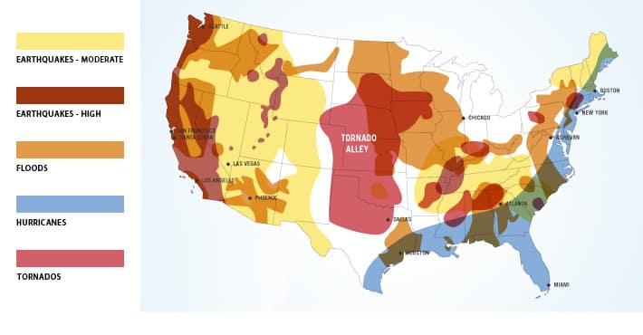

**2.1 Earthquakes**

Although coastal regions are highly susceptible to hurricanes, Tsunami, and other climatic hazards, pacific-coast regions are mainly subjected to earthquakes.

[Hazards part should discuss about the probability/susceptibility of occurrence of earthquakes, not a resilience, vulnerability, etc. frameworks – need a discussion on this map]

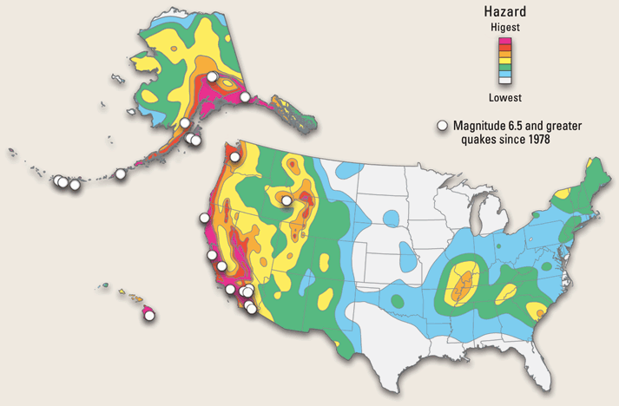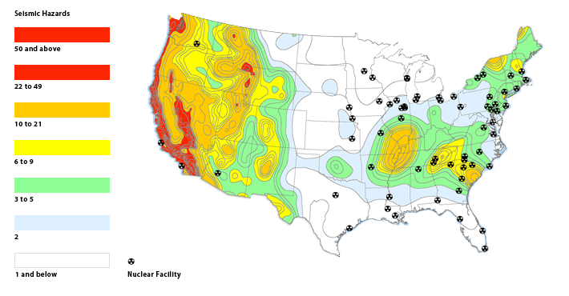

Discuss on the susceptibility of occurrence of earthquake throughout the United States [don’t need to be long paragraph]. 300-400 words on this should be sufficient.

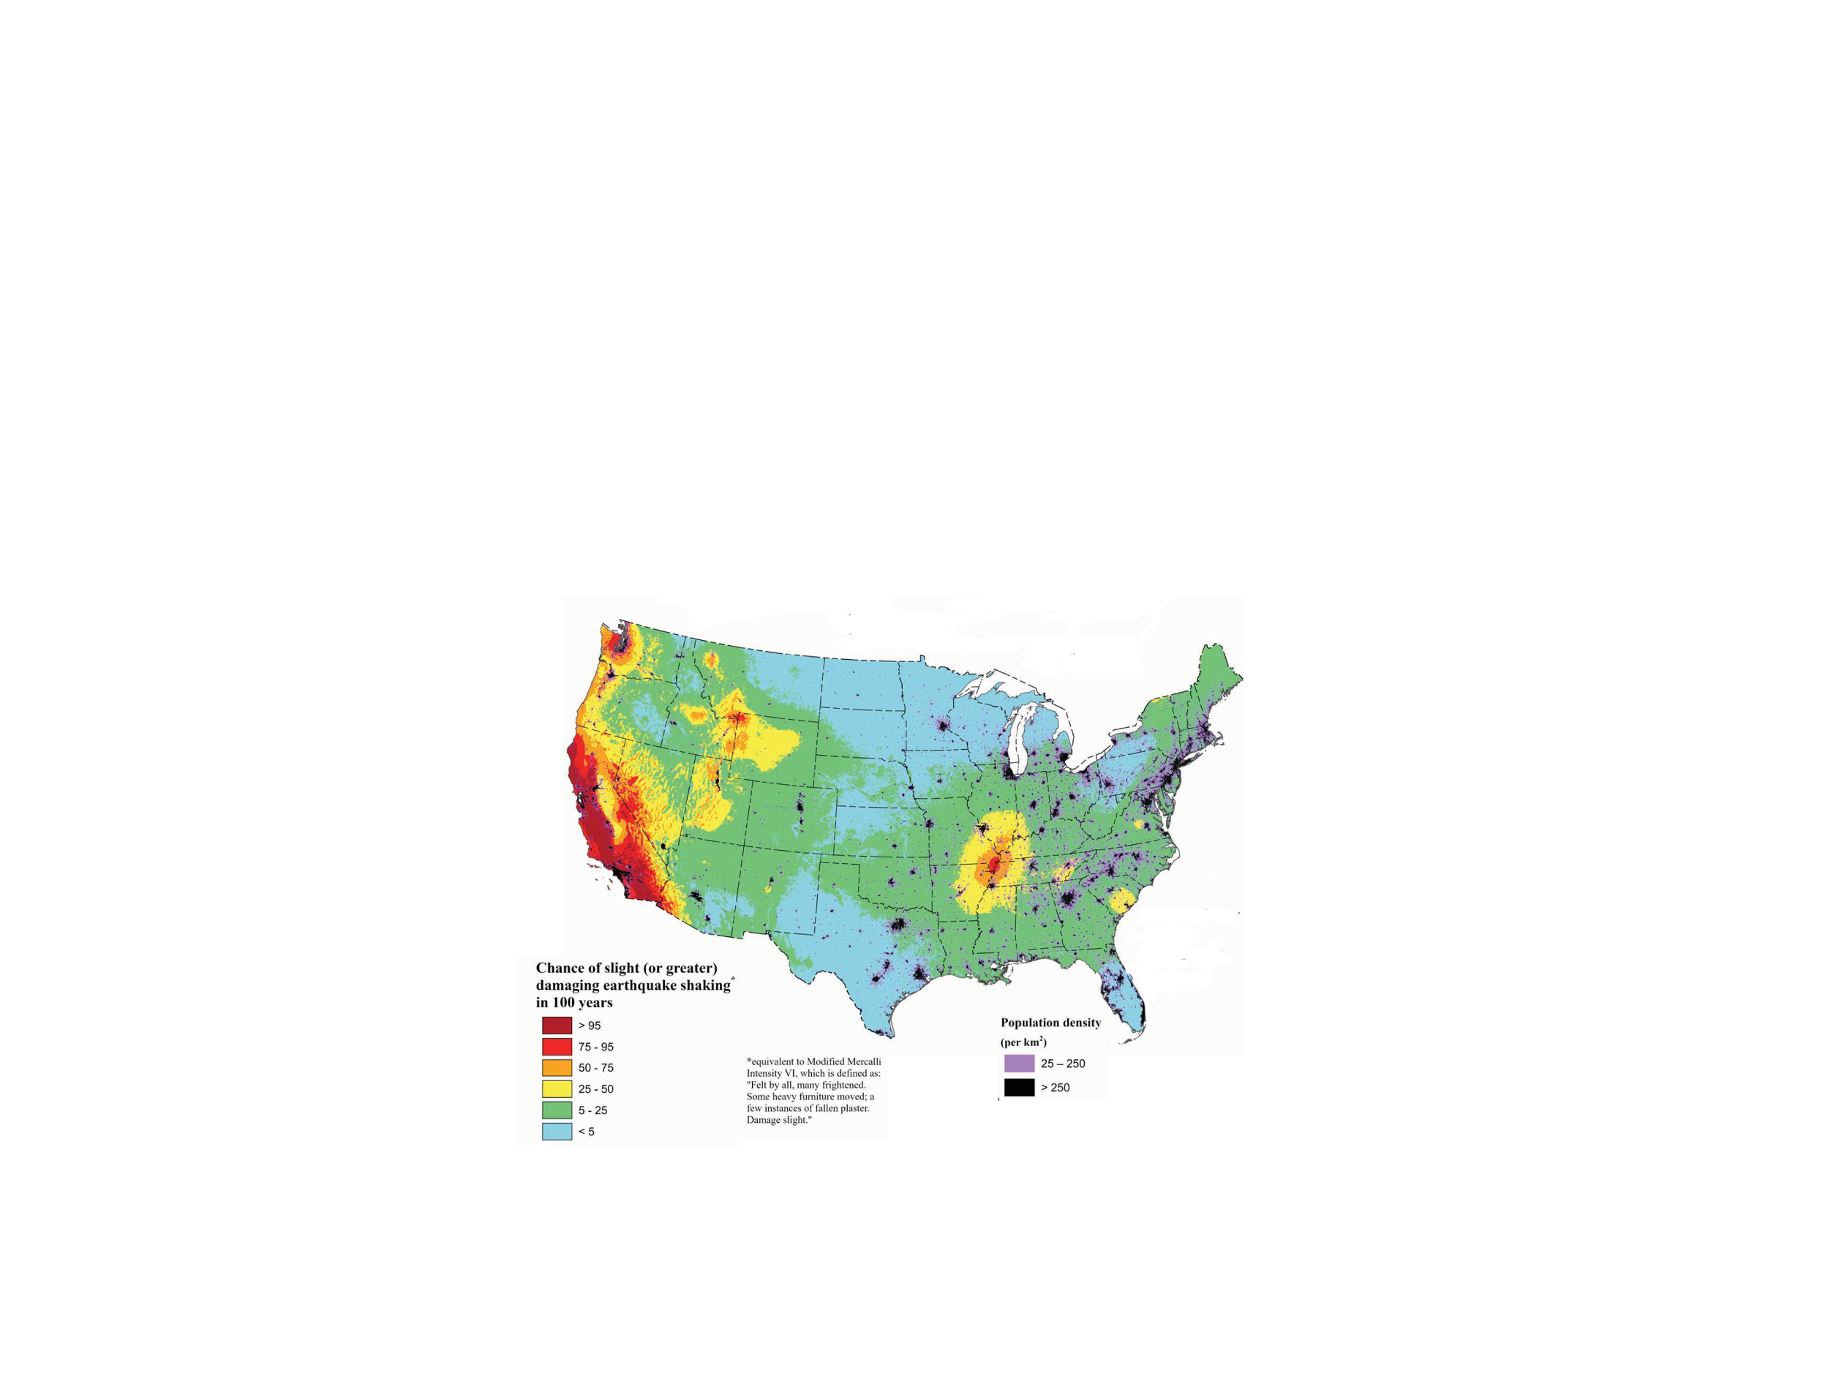Earthquakes can occur throughout the U.S., but the risk level differs by region. The Pacific coast is especially prone to earthquakes due to its location along tectonic plate boundaries ( Petersen et al. 2018; Shumway et al. 2024).

**Fig.** National Seismic HazardModel (2023)-changing of earthquake shaking

And California, particularly cities like Los Angeles and San Francisco, is at high risk for earthquakes. The state has experienced significant earthquakes in the past, such as the 1906 San Francisco earthquake and the 1994 Northridge earthquake (USGS, 1906; Wortman et al., 1994).

The central United States also face seismic risks. In these regions, earthquakes can occur along intraplate faults, which are faults located within a tectonic plate rather than along its boundary such as the Meers and New Madrid sources (Shunway et al. 2024).

While the eastern U.S. generally has a lower seismic risk compared to the western regions, it is not entirely immune, and some earthquakes active near Maine and Virginia (Petersen et al. 2018). For instance, the 2011 Mw 5.8 Mineral, Virginia earthquake happened in the central Virginia (Horton et al. 2015; Shumway et al. 2024).

In conclusion, the susceptibility of the United States to earthquakes is significant and varies across different regions. The western United States, particularly areas along tectonic plate boundaries such as California, are at higher risk due to active fault lines like the San Andreas Fault. However, seismic activity can occur throughout the country, with regions in the central and eastern United States also experiencing significant ground shaking. This widespread seismic hazard necessitates understanding regional vulnerabilities, implementing effective building practices, and promoting earthquake preparedness to mitigate risks and enhance resilience.

**2.2 Hurricanes**

Discuss on the susceptibility of occurrence of hurricanes throughout the United States [don’t need to be long paragraph]. 300-400 words on this should be sufficient.

The likelihood of hurricanes occurring in the United States is affected by its geographical location, proximity to warm ocean waters, and atmospheric conditions. Different areas of the U.S. have varying levels of vulnerability to hurricanes. States along the Atlantic Ocean and the Gulf of Mexico, such as Florida, Louisiana, Texas, and the Carolinas, are particularly prone to hurricanes due to the warm waters in these regions (Mudd et al. 2014).

The Atlantic hurricane season, which officially runs from June 1 to November 30, is a period when tropical cyclones are most likely to form and impact these coastal areas see fig.

**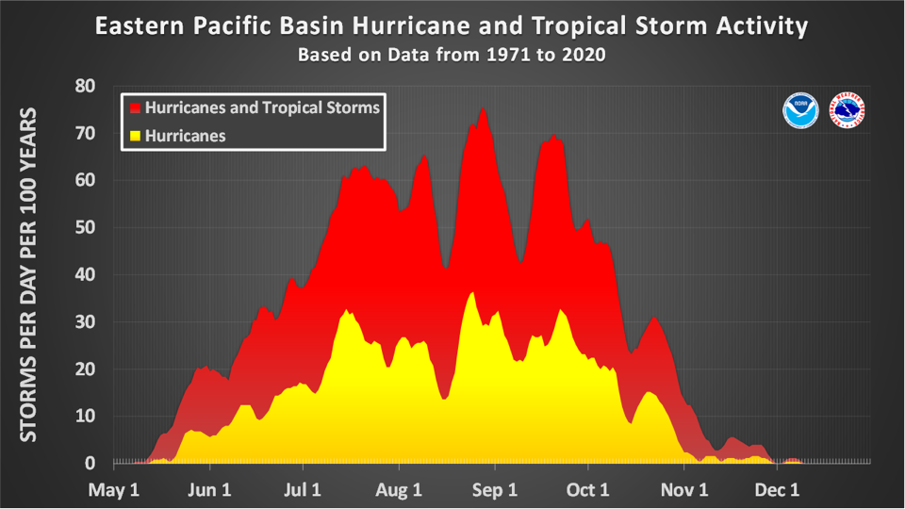Fig.** The Amount of tropical cyclone activity from 1971 to 2020 (source from NOAA)

While the northeastern states like New York and New England are less frequently hit by hurricanes compared to the southeastern states, they are not immune. Hurricanes can follow a northeastward track and impact these areas, as seen with historical storms like Hurricane Sandy in 2012 (CFNJ 2013).

Caribbean territories of the United States, such as Puerto Rico and the U.S. Virgin Islands, face a high risk of hurricanes. These areas often experience direct hits or significant impacts from passing storms during the hurricane season, like Hurricane Fiona, 2022 (Diaz 2022).

While the Pacific Coast is generally less susceptible to hurricanes, it is not entirely immune. Occasionally, hurricanes or their remnants can impact the southwestern U.S., bringing heavy rainfall and the potential for flooding. For example, Hurricane Hilary, 2023 affected southern California and caused floods and rainfall there and tens of thousands of southern California customers lost power (Reinhart et al. 2024).

**2.2.1 Hurricane-induced winds**

Add a discussion (150 words) on hurricane induced wind hazards. Again HAZARD, you should discuss anything related to vulnerability here.

**2.2.2 Hurricane-induced surge**

Add a discussion (150 words) on hurricane induced wind surges. Again HAZARD, you should discuss anything related to vulnerability here.

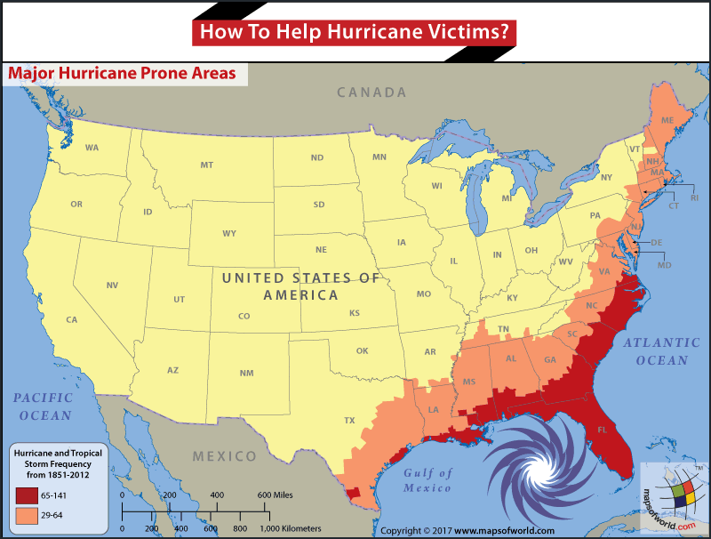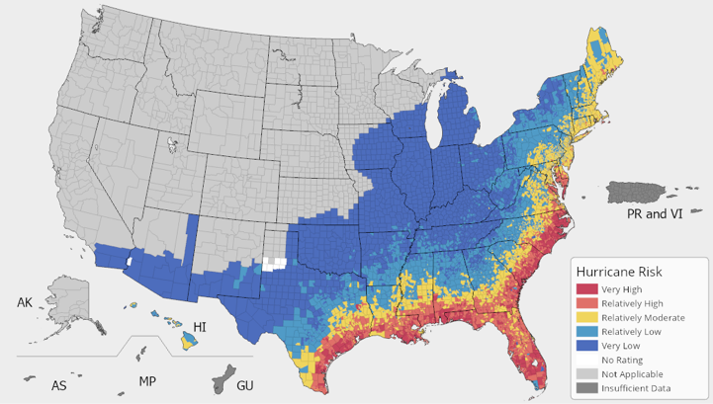

**2.3 Tsunami**

In the United States, tsunamis occur almost exclusively on the Pacific coast. Due to its geological location, the southern coast of Alaska is the most affected. Most tsunamis result from underwater earthquakes in the Pacific Ocean. Since the majority of the extreme events which happened along the coastline includes the following earthquake and tsunamis such as Indian Ocean (2004), Samoa (2009), Chile (2010), and Japan (2011) (Alam et al. 2019), it is urgent for people to analyze the earthquake-triggered tsunami hazards and develop accurate numerical models to simulate it (Rossetto et al. 2018).

**2.4 Floods**

[add 500 words discussion on following figure that will reflect flooding hazards in the US. See carefully, California and entire western coast are not subject to flooding – add reference of the following figure – replace by a better resolution figure]

Flooding hazards in the United States pose a significant and recurrent threat to the communities. Fig. shows the total rainfall distribution across the United States, highlighting regions with varying levels of precipitation. As Fig is shown, the southeastern states, including Louisiana, Mississippi, Alabama, Georgia, and Florida, display significant rainfall amounts, often exceeding 8 inches and reaching up to 20 inches or more in some areas. This high level of precipitation suggests a strong vulnerability to flooding, especially in low-lying and coastal regions where water drainage can be inadequate.

States along the eastern coast, such as South Carolina, North Carolina, Virginia, and the northeastern states, show substantial rainfall (ranging from 6 to 15 inches). The Midwest, including states like Kentucky, Tennessee, and parts of Missouri and Illinois, shows moderate rainfall levels (around 4 to 10 inches). While these areas are less prone to catastrophic flooding compared to the southeast, they still face risks.

The central and northern plains states, such as Texas, Oklahoma, and Kansas, exhibit lower rainfall levels (about 2 to 8 inches). Flooding risks in these regions are typically localized and occur during specific events, like thunderstorms or seasonal storms. Notably, California and the entire western coast, along with states like Nevada and Arizona, show minimal to no significant rainfall (less than 2 inches, mostly gray areas). This suggests a low risk of flooding in these regions.

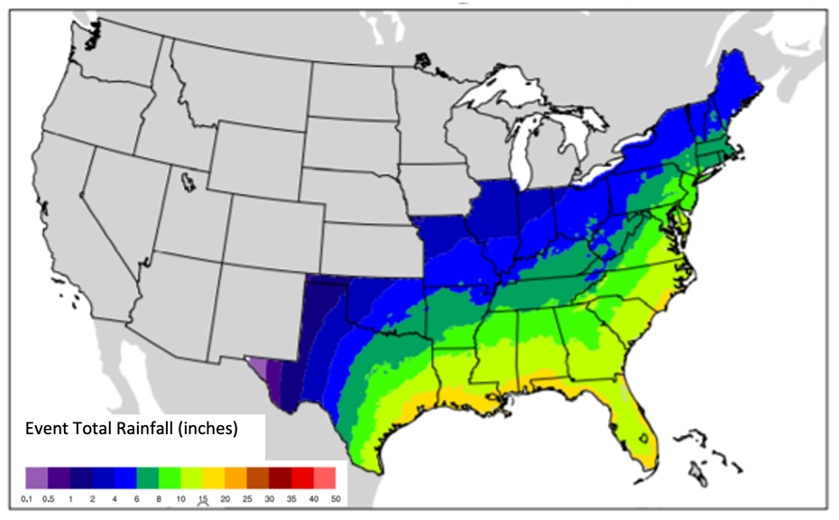Hence, the southeastern and Gulf Coast states are particularly susceptible to flooding due to high rainfall levels, while the western and southwestern regions show minimal flooding risk due to lower precipitation.

**Fig.** 100-year return period map of the event-level hurricane precipitation within the model domain of AIR’s U.S. hurricane model (Source AIR at <https://www.air-worldwide.com/blog/posts/2021/9/flood-risk-mid-atlantic-and-northeastern-us/>).

**2.5 Tornados**

[add a 500 words discussion on the following Tornado hazard zones]

The fig. illustrates the number of tornado watches issued per county across the United States in 2013, based on data from the National Weather Service Storm Prediction Center (SPC). The map highlights a significant concentration of tornado watches in the central United States, particularly in states such as Oklahoma, Kansas, Missouri, and parts of Texas, Arkansas, and Louisiana. These regions are known as “Tornado Alley,” where tornado activity is most frequent. The high density of dark purple in these areas indicates that many counties had more than 20 tornado watches issued, underscoring their high vulnerability to tornadoes.

States such as Alabama, Mississippi, and Tennessee also show a considerable number of tornado watches, reflected by the light to dark blue shades. While not as concentrated as in Tornado Alley, these regions still face a significant tornado risk, often associated with severe weather systems moving from the Gulf of Mexico.

The Midwest, including Illinois, Indiana, and Ohio, shows moderate tornado watch activity with varying shades of blue, indicating a moderate risk. Tornadoes in these regions can occur but are typically less frequent than in Tornado Alley. Besides, the western states, including California, Nevada, Oregon, and Washington, exhibit minimal tornado watch activity, indicated by the absence or very light blue shading on the map. These regions are generally considered low risk for tornadoes due to their geographic and climatic conditions. Similarly, the northeastern states such as New York, Pennsylvania, and New England show low tornado watch activity. While tornadoes can occur in these areas, they are relatively rare compared to other parts of the country.

**Fig.** Tornado watches issued by county, United States, 2013. (Source: NOAA NWS Storm Prediction Center at [www.spc.noaa.gov/wcm/](http://www.spc.noaa.gov/wcm/" \t "_blank))

## Table 1: List of Major Earthquake Disasters (100 years)

|  |  |  |  |  |  |  |
| --- | --- | --- | --- | --- | --- | --- |
| **Earthquake & Location** | **Magnitude (Mw) & Epicenter** | **Physical Loss description** | **Economic Loss** | **Environmental Impacts** | **Social Impacts** | **References** |
| 1906 San Francisco  (California) | 7.9, and  San Francisco  (37.75°N, 122.55°W) | * 28,188 buildings were destroyed in San Francisco. | $400 million  (1906) | * The earthquake permanently shifted the course of the Salinas River near its mouth. | * More than 3,000 fatalities, with 498 in San Francisco, 64 in Santa Rosa, and 102 in and near San Jose. * 225,000 people homeless. | (USGS 1906) |
| 1925 Santa Barbara  (California) | 6.5, and  Santa Barbara  (34.3°N, 119.8°W) | * An area of about 36 blocks had to be completely demolished and rebuilt. | $8 million  (1925) | * No obvious environmental loss. | * 13 fatalities. * 120 schools in and around the Long Beach area were damaged, of which 70 were destroyed. | (SCEDC 2023) |
| 1933 Long Beach  (California) | 6.4, and  Long Beach  (33.65°N, 117.98°W) | * Broken gas lines. | $50 million  (1933) | * Liquefaction in Long Beach, Hunting Park, Compton and other areas. * Oil derricks were shaken out of the ground in Huntington Beach. | * 120 fatalities. | (Parrish 1933) |
| 1946 Aleutian Islands  (Alaska) | 8.6, and  Aleutian Islands  (52.8°N, 163.5°W) | * All houses on the main street facing Hilo Bay were ripped off its foundation. | $26 million  (1946) | * Completely destroyed waterfront in Hilo. | * 165 fatalities. | (Pararas-Carayannis 1969) |
| 1952 Kern County  (California) | 7.3, and  Lebec  (34.86°N,119.10°W) | * Hundreds of buildings were damaged in Kern County area. * The collapse of a section of the Southern Pacific Railroad line near Bear Mountain. | $750 million  (1952) | * No obvious environmental loss. | * 142 fatalities, at least 18 injuries. | (SCEDC 2023) |
| 1959 Hebgen Lake  (Montana) | 7.2, and  West Yellowstone  (44.86°N, 111.33°W) | * Embankment settlement to Hebgen Dam. * Cracking of the concrete core wall. * Significant spillway damages. | $11 million  (1959) | * A huge landslide blocked the flow of the Madison River, resulting in the creation of Quake Lake. | * 28 fatalities. | (Mauney 2022) |
| 1964 Alaska  (Alaska) | 9.2, and  Anchorage  (61.09°N, 147.96°W) | * Water, sewer and gas line breaks and widespread telephone and electrical failures. | $300 million  (1964) | * Landslides. * Coastal forests plunged below sea level and were destroyed by salt water. * Soil liquefaction in the Turnagain Heights area of Anchorage. | * 143 fatalities. | (History 2018) |
| 1971 San Fernando  (California) | 6.6, and  San Fernando  (34.42°N, 118.40°W) | * Four 5-story wings pulled away from the main building and three of them toppled at Olive View. | $500 million  (1971) | * No obvious environmental loss. | * 64 fatalities. * Two buildings at the San Fernando Veterans Administration Hospital were destroyed. | (USGS 2021) |
| 1989 Loma Prieta  (California) | 6.9, and  Loma Prieta  (37.04°N, 121.88°W) | * 18,306 houses were damaged and 963 were destroyed. 2,575 businesses were damaged and 147 were destroyed. | $6.8 billion  (1989) | * Soil liquefaction in San Francisco's Marina District. * Vent of a sand volcano produced by liquefaction is about 4 feet. | * 63 fatalities, 3757 were reported injured and 12,053 displaced. * The collapse of the elevated Cypress Structure section of Interstate 880 in Oakland, the collapse of a section of roadbed on the Bay Bridge, and extensive damage to downtown Santa Cruz and San Francisco's Marina District. | (CGS 1989) |
| 1994 Northridge  (California) | 6.7, and  Northridge  (34.21° N, 118.54°W) | * 82,000 residential and commercial units and 5,400 mobile homes were damaged or destroyed. * About 200 large steel frame buildings suffered severe structural damages, nine parking structures collapsed, and nine local hospitals had structural and nonstructural system failures. * Seven major freeway bridges in the area collapsed, and 212 were damaged. | $49 billion  (1994) | * No obvious environmental loss | * 57 fatalities and over 9,000 injuries. 125,000 people became temporarily homeless. | (ECA 2014) |

Discussion on Hurricanes

## Table 2: List of Major Hurricane Disasters (100 years)

|  |  |  |  |  |  |  |
| --- | --- | --- | --- | --- | --- | --- |
| **Hurricane and Location** | **Category and**  **Coordinate (x, y) for plotting in GIS** | **Physical Loss description** | **Economic Loss**  **(Billions of USD)** | **Environmental Loss** | **Social Impacts** | **References** |
| Hurricane Betsy (1965)  (FL, LA) | Category 4, and  Grand Isle  (29.233°N, 89.999°W) | * 154,000 homes were flooded, with most located in the Lower Ninth Ward, Louisiana | $1.4 | * No obvious environmental loss | * At least 70 fatalities. | (LSU 1965) |
| Hurricane Camille  (1969)  (MS, LA, AL, VA) | Category 5, and  Bay St. Louis  (30.319°N, 89.334°W) | * More than 133 bridges were wiped out in the mountain region of Nelson County, VA. * 8,931 people were injured, 5,662 homes were destroyed, and 13,915 homes experienced major damage or were completely destroyed. | $1.4 | * Approximately 20,000 acres of corn was flattened in southeast Mississippi, Dauphin Island. | * 259 fatalities. | (NOAA 1969; Hurricane science 1969) |
| Hurricane David (1979)  (FL) | Category 5, and  Miami  (26.722°N, 80.058°W) | * About half the trailers at Ocean Holiday Travel Park were destroyed. | $1.5 | * No obvious environmental loss | * 2,078 fatalities, with 2,000 in Dominican Republic and 15 in United States. * Around 70,000 people lost electricity in or near West Palm Beach. | (Hebert 1980; Raines 1979) |
| Hurricane Allen  (1980)  (TX) | Category 5, and  South Padre Island  (26.116°N, 97.168°W) | * Two $30 million-dollar platforms were destroyed. | $1.6 | * No obvious environmental loss. | * 269 fatalities. | (NOAA 1980) |
| Hurricane Hugo (1989),  (SC) | Category 5, and  Sullivan’s Island  (32.763°N, 79.834°W) | * The homes of more than 200,000 families were damaged with 129,687 families in South Carolina, 87,700 families in Puerto Rico and the U.S. Virgin Islands. | $14.1 | * Approximately three-quarters of the trees in this 250,000-acre national forest were blown down. * 4.5 million acres of forestland was damaged in South Carolina alone. * Hurricane Hugo deposited a large number of exotic birds at lakes in Western North Carolina. | * 70 fatalities. | (NOAA 1989) |
| Hurricane Iniki (1992),  (HI) | Category 4, and  Kauai  (22.09°N, 159.52°W) | * About 100 people were injured. * 14,350 homes were affected with 1,421 destroyed and 5,152 suffering major damage in Kauai. | $3.1 | * No obvious environmental loss. | * 7 fatalities. | (NOAA 1993) |
| Hurricane Andrew (1992),  (FL) | Category 5, and  Elliott Key  (25.441°N, 80.197°W) | * 25,524 homes were destroyed and 101,241 were damaged. * Over 120 homes were demolished, and 700 others were damaged. In the small town of Florida City. * 23,000 homes were damaged, and 985 homes and 1,951 mobile homes were destroyed in Louisiana. | $25 | * The Louisiana barrier island shoreline is eroding at a rate exceeding 20 meters per year because of both hurricanes and normal processes. * 177,000 people were homeless. | * 65 fatalities. | (Rappaport 1993; USGS 1992) |
| Hurricane Opal (1995)  (FL) | Category 4, and  Pensacola Beach  (30.352°N, 87.051°W) | * Nearly 300 homes were destroyed, and 1,000 others suffered major damage. | $3 | * Minor to moderate beach and shore erosion, especially the western end of lake. | * 63 fatalities, with 13 in the United States. * Nearly 2 million people lost power in Florida, Alabama, Georgia, and the Carolinas. | (Mayfield 1995) |
| Hurricane Georges (1998)  (LA, FL, PR) | Category 4, and  Puerto, Rico  (18.333°N, 65.634°W) | * 1536 homes were damage of which 173 were completely destroyed in the Florida Keys. | $9.3 | * Minor beach erosion along the island in Florida | * Over 200,000 had no power in Miami. * 167,332 people were homeless in Haiti. | (Guiney 1999) |
| Hurricane Mitch (1998)  (FL) | Category 5, and  Naples  (26.143°N, 81.798°W) | * 645 houses were damaged or destroyed. | $6.1 | * No obvious environmental loss | * 2 fatalities and 65 injuries in Florida * 100,000 people lost electricity. | (Guiney and Lawrence 1999) |
| Hurricane Floyd (1999)  (NC, PA, NJ) | Category 4, and  Palm Beach  (26.710°N, 80.039°W) | * 56,000 homes were damaged, with 7,000 destroyed and leaving 17,000 uninhabitable. | $6.5 | * An increased load of nutrients and decreased levels of oxygen and salt in estuaries. | * 85 fatalities. * 500,000 lost electricity in North Carolina. | (Pasch et al. 1999; Mosher 2000) |
| Hurricane Lili (2002)  (LA) | Category 4, and  Intracoastal City (29.784°N, 92.156°W) | * Nearly 4000 homes were major damaged in Vermillion Parish. | $1.2 | * No obvious environmental loss | * 15 fatalities * 237,000 people lost power and oil rigs offshore were shut down for up to a week. | (Lawrence 2003) |
| Hurricane Isabel (2003)  (NC, VA, MD) | Category 5, and  Outer Banks  (35.557°N, 75.466°W) | * Thousands of houses were damaged across eastern North Carolina. * 44 million US gallons of water flooded the Midtown Tunnel in Virginia. | $5.5 | * An estimated 18,300 ft of county shoreline, about 1.5% of the county’s total shoreline length in Baltimore County. * A total of 158,000 metric tonnes of sediment in the Western Shore of Maryland’s Chesapeake Bay. | * 35 fatalities. * 700,000 residents lost power in North Carolina. | (Beven and Cobb 2004; Hennessee and Halka 2004) |
| Hurricane Ivan (2004),  (FL, AL) | Category 5, and  Mobile  (30.683°N, 88.117°W) | * The Interstate 10 Escambia Bay Bridge was heavily damaged. | $26.1 | * 165 km2 of land was inundated in Pensacola Bay, Florida. * Freshwater discharge from the largest river increased twentyfold during the subsequent 4 days, stimulating a modest phytoplankton bloom and maintaining hypoxia for several months. | * 64 fatalities. * Electrical grid was damaged in Alabama and 489,000 people had lost electrical power. | (Stewart 2004; Hagy et al. 2006) |
| Hurricane Frances (2004)  (FL) | Category 4, and  Panhandle  (26.288°N, 81.485°W) | * 15,000 houses and 2,400 businesses were damaged in Palm Beach County | $10.1 | * Beach and dune erosion on the open coast of Florida | * At least 9 fatalities. * 659,000 customers lost power in Palm Beach, 590,000 in Broward, 426,000 in Miami-Dade,39,200 in Collier and 2,500 in Hendry. | (Beven 2005; NOAA 2004) |
| Hurricane Charley (2004)  (FL, NC, SC) | Category 4, and  Cayo Costa  (26.659°N, 82.243°W) | * 23,000 buildings were damaged, with 739 structures destroyed in Lake Wales, Florida. | $15.1 | * A 1,600-foot bread was created in North Captiva Island from Hurricane Charley. * 118,000 cubic yards of material were lost in Captiva Island. | * 15 fatalities. * 2 million customers lost electricity in Florida. | (Pasch et al. 2004; Neal 2005) |
| Hurricane Katrina (2005),  (LA, MS, AL, FL) | Category 5, and  Hallandale Beach  (25.978°N, 80.143°W) | * 80 % of the city in New Orleans was flooded. * 81% (20,229) of the housing units were damaged in St. Bernard Parish, 70 % (48,792) were damaged in St. Tammany Parish and 80% (7,212) were damaged in Plaquemines Parish | $125 | * The storm surge caused substantial beach erosion. The sand that comprised the islands was transported across the island into the Mississippi Sound in Dauphin Island. * Overall, about 20% of the local marshes were permanently overrun by water. * Leak of oil exceeded 7.2 million gallons. * 20.5% of the trees were loss. * Lake Pontchartrain was contaminated by the floodwaters in New Orleans. | * 1,392 fatalities. * 1.45 million people without power in Florida. | (Dolfman et al. 2007; Knabb et al. 2023) |
| Hurricane Rita  (2005)  (LA, TX) | Category 5, and  Johnson’s Bayou  (29.762°N, 93.697°W) | * 4,526 single-family dwellings were destroyed, 14,256 were major damaged and 26,211 were minor damaged in Orange and Jefferson counties in Southeast Texas. | $18.5 | * Deposit of salt water in the soil in Vermilion Parish and soil salinity levels rise between 268 to 4,329 ppm | * At least 55 fatalities in Texas. | (Knabb et al. 2006; Herbert 2014) |
| Hurricane Dennis (2005)  (FL, AL, GA) | Category 4, and  Florida Panhandle  (29.977°N, 85.434°W) | * Significant tree and power line damage. | $4.0 | * Major beach and dune erosion (condition IV) was sustained throughout Dog Island, Franklin County. | * 42 fatalities – 22 in Haiti, 16 in Cuba, 3 in the United States. * Estimated 400,000 people were without power. | (Beven 2005; NOAA 2005; Clark 2005) |
| Hurricane Ike (2008)  (TX, LA) | Category 4, and  Galveston  (29.253°N, 94.890°W) | * In Bolivar Pennisula, approximately 3,600 were destroyed, 400 sustained major damage (like substantially damaged), 1,800 sustained some damage but were not substantially damaged, and only 100 were undamaged or sustained only minimal damage. * Eastern areas of Trinity and Galveston were inundated. | $38 | * At least 448 releases of oil, gasoline and dozens of other substances into the air and water and onto ground in Louisiana and Texas. | * 196 fatalities, with 113 in the United States. * 2.6 million customers lost power in Texas and Louisiana. | (Berg 2009; FEMA 2009; NBC News 2008) |
| Hurricane Sandy (2012),  (NY, NJ, CT) | Category 3, and  Brigantine  (39.830°N, 74.252°W) | * 650,000 homes were destroyed. | $70 | * The devastation of Delaware Bay beaches. | * 147 fatalities. | (World vision 2012; CFNJ 2013) |
| Hurricane Matthew (2016)  (FL, NC, SC) | Category 5, and  McClellanville  (33.085°N, 79.470°W) | * 100,000 structures were flooded.[[4]](#footnote-4) | $16.5 | * In Jacksonville, Matthew caused major sand dune and flooding in the St. Johns River * 230,000 trees were downed on Hilton Head Island, South Carolina. | * 34 fatalities across North Carolina. * 680,000 in North Carolina were without power. | (Stewart 2017) |
| Hurricane Maria (2017),  (PR) | Category 5, and  Yabucoa  (18.051°N, 65.878°W) | * Around 130,000 Puerto Ricans were homeless between July 2017 and July 2018. | $91.61 | * 40,000 landslides in Puerto Rico. * 30 % of the trees were destroyed. * Nitrate in drinking water. * Poor Air and Water Quality. * Loss of wildlife. | * Around 2,975 fatalities. | (Bandoim 2019; Mehta 2021) |
| Hurricane Irma (2017),  (FL) | Category 5, and  Cudjoe Key  (24.669°N, 81.495°W) | * More than 7,000 homes sustained damage including 450 that were destroyed or suffered major damage in Brevard County. * About 4,000 structures were damaged in Osceola County. | $50 | * Inundation of the Kissimmee River floodplain. * A severe dissolved oxygen crash and fish kill in June followed by another crash in September after Hurricane Irma. | * 139 fatalities. | (Cangialosi et al. 2018; SFWMD 2017) |
| Hurricane Harvey (2017),  (TX) | Category 4, and  San José Island  (27.833°N, 97.052°W) | * More than 290,000 homes were damaged, with nearly 17,000 destroyed. * At least 160,000 structures were flooded in Harris and Galveston counties alone. * More than 300,000 vehicles were destroyed by flooding in the Houston region. | $125 | * Floodwaters were contaminated. * Millions of gallons of untreated sewage overflows occurred. * More than 700,000 gallons of pollutants released into water and on land, and more than 38,000 pounds of air pollutants. * The San Jacinto Waste Pits Superfund site was damaged by Harvey and has released dioxin into the river. | * 100 fatalities. | (STEDC 2018; LSC 2021) |
| Hurricane Michael (2018)  (FL, GA, LA) | Category 5, and  Mexico Beach  (30.694°N, 86.108°W) | * 45,000 structures were damaged and 1,500 were destroyed in Bay County. | $25.5 | * Damage to over 2.8 million acres of forested land in Florida. | * At least 74 fatalities. | (Beven et al. 2019) |
| Hurricane Dorian (2019)  (FL, NC) | Category 5, and  Elbow Cay  (26.510°N, 76.977°W) | * The main airport terminal on Grand Bahama was destroyed. * More than 75 % of all the homes on the Abaco Islands were either damaged or destroyed. | $3.4 | * The affected islands of Abaco and Grand Bahama were completely inundated with sea water. * Grand Bahamians draw water was contaminated with salt water. | * 74 fatalities. * 29,500 people were homeless. | (Mercy Corps 2020) |
| Hurricane Laura (2020)  (PR, LA, FL) | Category 4, and  Cameron  (29.785°N, 93.248°W) | * 10,000 homes were demolished in Louisiana. | $23.3 | * Large swathes of land and water that appeared coated with oil in Cameron, Louisiana. | * 81 fatalities. * Roughly 200,000 customers lost power in Puerto Rico, with nearly 14,000 losing access to running water. * 568,000 people were without power across Louisiana and Texas. | (Pasch et al. 2021; Sturgis 2020) |
| Hurricane Delta (2020)  (LA) | Category 4, and  Creole  (29.796°N, 93.111°W) | * Around 5,600 homes were destroyed. | $3.0 | * No obvious environmental impact. | * 4 Fatalities. * 740,000 people were power outage. | (Cangialosi and Berg 2021) |
| Hurricane Ida (2021)  (LA, NJ, NY) | Category 4, and  Port Fourchon  (29.105°N, 90.195°W) | * More than 1,000 buildings were destroyed in Venezuela. * About 3,839 oil and gas rigs, wells and thousands of pipelines were damaged. | $75.2 | * Subsidence, paired with sea level rise spurred by climate change, results in significant, extensive land loss in coastal Louisiana and offshore. | * 55 fatalities. * More than 560,000 power outages. | (Beven et al. 2022; Yorder and Moore 2022) |
| Hurricane Fiona (2022)  (PR) | Category 4, and  Punta Tocon  (17.947°N, 67.110°W) | * All aspects of the grid were damaged, including substations and high voltage power lines. | $3.4 | * Heating up the deeper layers and cooling off the surface layer about 6 C. | * At least 21 fatalities. * More than 900,000 people 一were without power in Puerto Rico. | (Diaz 2022; CBC News 2022) |
| Hurricane Ian (2022),  (FL, NC, SC) | Category 5, and  Cayo Costa Island  (26.686°N, 82.25°W) | * At least 52,514 structures were impacted of which 5,369 were destroyed and 14,245 received major damage in Lee County, Florida. * More than 2.4 million people lost power. | $113.1 | * The hurricane destroyed the artificial reefs that are essential to Florida’s underwater ecosystems and caused toxic algal blooms that harm birds and fish. | * 149 fatalities. | (Bucci et al. 2022; Aaditi 2022) |

Discussion on tornados.

**Table 3: List of Major Tornadoes Disasters (100 years)**

|  |  |  |  |  |  |  |
| --- | --- | --- | --- | --- | --- | --- |
| **Tornado & Location** | **The Enhanced Fujita Scale and**  **Coordinate (x, y) for plotting in GIS** | **Physical Loss description** | **Economic Loss**  **(Millions of USD)** | **Environmental Impacts** | **Social Impacts** | **References** |
| April 1920 Tornado  (MS, AL, TN) | EF5, and  Oktibbeha County  (33.450°N, 88.909°W) | * More than 200 homes were flattened in Mississippi. | $2 | * No obvious environmental loss | * 88 fatalities. | (NOAA 2023) |
| 1924 Lorain-Sandusky Tornado  (OH) | EF5, and  Lorain-Sandusky  (41.445°N, 82.188°W) | * 500 homes were destroyed in Ohio | $12 | * No obvious environmental loss. | * 85 fatalities. * 7,000 people were homeless | (NOAA 2023; Cleveland Memory 2023) |
| 1925 Tri-State Tornado  (MO, IL, IN) | EF5, and  Reynolds County  (37.393°N, 91.074°W) | * About 85 farms were devasted and the towns were demolished in Griffin, Owensville, Indiana. | $16 |  | * 695 fatalities, 13,000 people injured. * Thousands of people were homeless and without food | (NOAA 2023; History Channel 2023) |
| 1927 Tornado  (MO) | EF5, and  Poplar Bluff  (36.759°N, 90.399°W) | * Hundreds of automobiles were crushed beneath tons of brick, steel and timber and buildings and homes were leveled. * Every business block on Main Street and Broadway was damaged. | $2.1 |  | * 98 fatalities. * The East Side school building was partly demolished. | (NOAA 2023; Deem 2002) |
| 1936 Tupelo Tornado  (MS) | EF5, and  Tupelo  (34.258°N, 88.719°W) | * Hundreds of structures were flattened in western Lee County. * Estimated property damaged totaling was over 3 million dollars. | $3 |  | * 216 fatalities, with 700 injured. * The tornado heavily damaged the Tupelo hospital, leaving hundreds of injured people in need of care. | (NOAA 2023; Fortenberry 2020) |
| 1936 Gainesville Tornado  (GA) | EF5, and  Gainesville  (34.296°N, 83.826°W) | * About 750 homes were destroyed and 254 were severely damaged in the city of Gainesville. | $13 |  | * 203 fatalities, and 1,600 injured. * The power grid, water system and communications systems were completely disrupted during the incident. * Nearly all major roadways were blocked in Gainesville. | (NOAA 2023; Eller 2021) |
| 1944 Appalachians Tornado outbreak  (WV) | EF5, and  Central  (39.347°N, 81.514°W) | * 15 homes were destroyed across Indiana County. * In the Indiana Gazette, the Lutheran Church at Rural Valley was completely destroyed. * 53 small homes were destroyed at the coal mining community of Chartiers. | $6 |  | * 100 fatalities. * Route 119 was blocked from downed trees and other debris. | (NOAA 2023; Wilkes 2020) |
| 1947 the Woodward Tornado  (OK) | EF5, and  Woodward  (36.432°N, 99.394°W) | * Over 1000 homes and businesses were destroyed on Woodward. | $8 |  | * 181 fatalities, and nearly 1000 injured. * Over 100 city blocks on the west and north sides of the city were destroyed. | (NOAA 2023; NOAA 1947) |
| 1953 Flint-Beecher Tornado  (MI) | EF5, and  Flint  (41.426°N, 81.813°W) | * 340 homes were destroyed, 107 suffered “major damage”, and 153 suffered “minor damage”. * 66 buildings were destroyed or damaged to farms, businesses and other buildings in Detroit/Pontiac, Michigan. | $19 |  | * 115 fatalities, and at least 844 injured. * Several hospitals were damaged including Hurley, St. Joseph, Flint General, Flint Osteopathic, and McLaren General in Genesee County, and St. Mary, St. Luke, and Saginaw General in Saginaw County. | (NOAA 2023; NOAA 2003) |
| 1953 Waco Tornado  (TX) | EF5, and  Waco  (31.549°N, 97.162°W) | * Damage or destruction of 519 homes, 19 businesses, and 150 cars. In the eastern Texas Panhandle. * Totally over 500 homes and businesses were destroyed and over 1000 were damaged. * 2000 vehicles also sustained damage. | $41 |  | * 114 fatalities, and 597 injured. | (NOAA 2023; NOAA 2006) |
| 1953 Worcester Tornado  (MA) | EF5, and  Worcester  (42.266°N, 71.806°W) | * 4,000 buildings were damaged or destroyed. | $52 |  | * 94 fatalities with 1,228 injured. * Ten thousand residents or 5% of the population lost their home in Worcester County. | (NOAA 2023; Jacobson 2023) |
| 1955 Udall Tornado  (OK, KS) | EF5, and  Udall  (37.387°N, 97.114°W) | * Most of the south-central Kansas town of about 500 people was leveled. * 192 buildings and 170 homes were destroyed. | $8 |  | * 100 fatalities, and at least 250 injured. | (NOAA 2023; Kansas Historical Society 2004) |
| 2011 Joplin Tornado  (MO) | EF5, and  Joplin  (37.083°N, 94.514°W) | * 4,380 homes were destroyed and another 3,884 significantly damaged. * 553 business structures were destroyed or damaged. | $3,000 |  | * 158 fatalities, more than 1,300 injured. * 130 transmission poles were damaged, contributing to lengthy power outages | (NOAA 2023; KY3 2022) |

## Table 4: List of Major Flooding Induced by Hurricanes (100 years)

|  |  |  |  |  |  |  |
| --- | --- | --- | --- | --- | --- | --- |
| **Flooding & Location** | **Category and**  **Coordinate (x, y) for plotting in GIS** | **Physical Loss description** | **Economic Loss**  **(Billions of USD)** | **Environmental Impacts** | **Social Impacts** | **References** |
| 1900 Galveston | Category 4, and  Galveston  (29.253°N, 94.890°W) | * About 7,000 buildings were destroyed. | $1.25 | * The surge heights reach 8 to 12 ft above the ground level. | * More than 8,000 fatalities. | (Britannica et al 2023) |
| 1938 New England | Category 5, and  Long Island  (40.793°N, 73.307°W) | * More than 57,000 homes were damaged or destroyed. | $0.62 | * Tides reach 16.75 ft in Long Island | * About 8000 fatalities. | (NOAA 2020) |
| 1957 Audrey | Category 3, and  Cameron  (29.796°N, 93.308°W) | * More than 4,500 homes were damaged or destroyed. | $0.15 | * Tides exceeds 12 ft, peaking at 12.4 ft in west of Cameron. | * More than 431 fatalities. | (NOAA 1957) |
| 1969 Camille | Category 5, and  Bay St. Louis  (30.319°N, 89.334°W) | * 5,662 homes were destroyed. * 13,915 homes experienced major damage. | $1.42 | * The surge heights reach up to 10 inches near Guane. | * 153 fatalities in Nelson County, Virginia. * 8,931 people were injured. | (NOAA 1969; Hurricane science 1969) |
| 1989 Hugo | Category 5, and  Sullivan’s Island  (32.763°N, 79.834°W) | * More than 200,000 families were damaged or destroyed. | $8.7 | * The surge heights reach 20.2 ft near McClellanville, South Carolina. | * 107 fatalities | (NOAA 1989) |
| 1992 Andrew | Category 5, and  Elliott Key  (25.441°N, 80.197°W) | * 101,241 homes were damaged or destroyed throughout Florida. | $0.5 | * Tides between 4 and 6 ft. | * 65 fatalities. | (Rappaport 1993; USGS 1992) |
| 1995 Opal | Category 4, and  Pensacola Beach  (30.352°N, 87.051°W) | * 300 homes were destroyed and 1,000 suffered major damage | $2.1 | * 8 to 15 ft storm surge heights in Florida. | * 31 fatalities. * About 34,000 people homeless. | (Mayfield 1995) |
| 2003 Isabel | Category 5, and  Outer Banks  (35.557°N, 75.466°W) | * Thousands of houses were damaged. | $5.5 | * The storm surge produced a 2,000 ft wide inlet on Hatteras Island. | * 51 fatalities. * Up to 700,000 residents without power. | (Beven and Cobb 2004; Hennessee and Halka 2004) |
| 2005 Katrina | Category 5, and  Hallandale Beach  (25.978°N, 80.143°W) | * Approximately 95,000 residential buildings were damaged in the city of New Orleans. | $16 | * The surge heights reach 23 ft. | * 1,836 fatalities. * 1.45 million people without power. | (Dolfman et al. 2007; Knabb et al. 2023) |
| 2008 Ike | Category 4, and  Galveston  (29.253°N, 94.890°W) | * 95% of the houses were damaged in Grand Turk Isaland. | $2.5 | * The surge heights reach 15 ft. | * 195 fatalities. | (Hurricanes 2023) |
| 2012 Sandy | Category 3, and  Brigantine  (39.830°N, 74.252°W) | * 800 buildings were destroyed, and 70,000 housing units sustained some level of damage. | $8.1 | * The surge heights reach 13 ft. | * 43 fatalities. * 90% of Long Island without power | (Strauss et al. 2021; Hatzikyriakou et al. 2018; NYC 2023) |
| 2016 Matthew | Category 5, and  McClellanville  (33.085°N, 79.470°W) | * 100,000 structures were flooded. | $10 | * The peak surge was 9.88 ft in Fernandina Beach, Florida | * 47 fatalities. | (Sutley et al. 2021; Stewart 2017; Khajehei 2019) |
| 2017 Harvey | Category 4, and  San José Island  (27.833°N, 97.052°W) | * At least 160,000 structures were flooded in Harris and Galveston counties alone | $3 | * The downtown area was inundated by 10 ft of water in Bay City. | * 107 fatalities. | (Sebastian et al. 2017; STEDC 2018; LSC 2021) |
| 2018 Michael | Category 5, and  Panhandle  (26.288°N, 81.485°W) | * 45,000 structures were damaged and 1,500 were destroyed in Bay County | $25.5 | * 9 – 14 ft above ground level along a portion of the Florida 17 coast form just southeast of Tyndall AFB to Port St. Joe in Bay and Gulf Counties, respectively. | * 74 fatalities. | (Beven et al. 2019) |
| 2019 Dorian | Category 5, and  Elbow Cay  (26.510°N, 76.977°W) | * More than 75 % of all the homes on the Abaco Islands were either damaged or destroyed. | $3.4 | * 5.55 ft above normal tide levels on the Pamlico Sound side of the Outer Banks. | * 74 fatalities. | (Mercy Corps 2020) |
| 2021 Ida | Category 4, and  Port Fourchon  (29.105°N, 90.195°W) | * More than 1,000 buildings were destroyed in Venezuela. | $75.2 | * 9 to 14 ft above ground level occurred along the east bank of Mississippi River in Plaquemines Parish. | * 55 fatalities. | (Beven et al. 2022; Yorder and Moore 2022) |
| 2022 Ian | Category 5, and  Cayo Costa Island  (26.686°N, 82.25°W) | * At least 52,514 structures were impacted of which 5,369 were destroyed and 14,245 received major damage in Lee County, Florida. | $113.1 | * Maximum inundation levels of 10 to 15 ft above ground level (AGL) occurred on Fort Myers Beach and Estero Island. | * 149 fatalities. | (Bucci et al. 2022; Aaditi 2022) |

1. Vulnerability analysis:

this section should include literature review on vulnerability of buildings and infrastructure systems categorically due to hazards that you discussed in the hazards analysis part.

**3.1 Earthquake:**

In a previous study, the idea of a fragility function within the field of earthquake engineering was traced back to Kennedy et al. (1980) who defined a fragility function as a probabilistic relationship between the frequency of failure of a nuclear power plant component and the peak ground acceleration during an earthquake. A common definition of fragility functions is defined as the conditional probability of attaining or exceeding prescribed limit states for a given set of demand variables (Ellingwood 2001; Gardoni 2002).

Building Vulnerability:

**Fig.** A fragility curve for amid-rise reinforced concrete moment frame building

Infrastructure Vulnerability:

**Fig.** Fragility curves for bridges and pipelines

**3.2 Hurricanes**: as same as the section 3.1 for Hurricane here

**3.3 Floods**

**3.4 Tornados**

**3.5 Tsunamis**

Satake (2014) investigates the 2004 Sumatra-Andaman earthquake which caused the worst tsunami disaster in countries around the Indian Ocean and find that the most effective method to reduce vulnerability is tsunami early warning systems. Additionally, tsunamis always cause extreme damage and casualty to the coastal community. Some studies investigate the probabilistic method and fragility curves which can quantitatively estimate the tsunami damage, while the models they chose do not provide a statistically analysis of the data. Charvet et al. (2014) propose advanced statistical methods to model the building damage in the 2011 event under tsunami and show that tsunami flow depth alone is not good enough to predict the tsunami damage and debris impact is main contribution to non-structural damage. Moreover, Suppasri et al. (2015) continue to develop 52 fragility curves based on data from the 2011 Tohoku-Oki tsunami and show that damage probability becomes higher along a ria coast due to higher velocities if the inundation depth is the same.

Some people (Alam et al. 2018; Attary et al. 2016; Petrone et al. 2017) investigate the analytical tsunami fragility function for far-field tsunamis. But only a few studies (Carey et al. 2019; Latcharote 2015; Park et al. 2012) consider the sequential earthquake shaking and tsunami inundation hazard. Alam et al. (2019) propose a probabilistic multi-hazard earthquake-tsunami fragility assessment framework. Reis et al. (2022) provide an integrated framework for the risk assessment of coastal structures under tsunami and earthquake hazards.

# Consequences

Paragraph 1. [600 – words long discussion on the consequences in the coastal communities due to various hazards. Discuss categorically by hazards and by buildings and infrastructures.].

Paragraph 2. [600 word-long Discuss on the impact on critical and essential facilizes, Add figures wherever necessary]

Paraph 3: [Add a 500 words discussion on social consequences].

# Risk Analysis

This section should discussion on the literature on risk analysis. What are the approaches are applied for different hazards. How past risk analysis has been beneficial.

# 6. resilience analysis

[Your goal is to provide what approaches has been applied to quantify resilience for coastal region categorically by different hazards] Your goal is not to represent what is resilience. Yes, you can briefly discuss on what is resilience but do not need unnecessary discussion on mathematical formula etc.]

## 6.1 Introduction to quantify resilience

Resilience, as discussed briefly in the introduction, has many definitions. The discussion of the term resilience is not the main point in the paper. Koliou et al. (2020) listed the representative definitions of term resilience. In this paper, the term resilience of a system includes the immediate system state in the aftermath of a disruption and the recovery process to achieve a desirable system state which means the system restore its original state or a higher one if desired (Mieler et al. 2015; Sharma et al. 2018).

Bruneau et al. (2003) first attempted to quantify the resilience of communities under seismic hazard. A Q(t) which is representative for the performance of system and can range from 0% to 100% has been introduced into a mathematical formulation and the resilience, R, is measured by the integral of the expected degradation in quality over time. Furthermore, the author proposed a well-known “4R” properties of resilience – Robustness, Redundancy, Resourcefulness, and Rapidity. However, the main problem of the measure is that only time is considered, and the recovery process is ignored so the formulation cannot distinguish different recovery curves.

Moreover, Chang & Shinozuka (2004) express the Bruneau et al. formulation in terms of a succinct and probabilistic formulation. Then Cimellaro et al. (2005, 2010a, 2010b) modified the Bruneau et al. formulation with a consideration of intensity measures, response parameters, performance threshold, performance measures, losses and recovery time and propose a detailed case study on the application to a hospital facility. Furthermore, Tokgoz and Gheorghe (2013) modified and applied the framework to a residential building based on different hurricane categories. However, all of these contributions to quantify the resilience of a system are measured by a simple metric, which cannot fully characterize the recovery curves with different shapes and might not be able to distinguish among the different resilience levels (Sharma et al. 2018).

## 6.2 A rigorous mathematical formulation

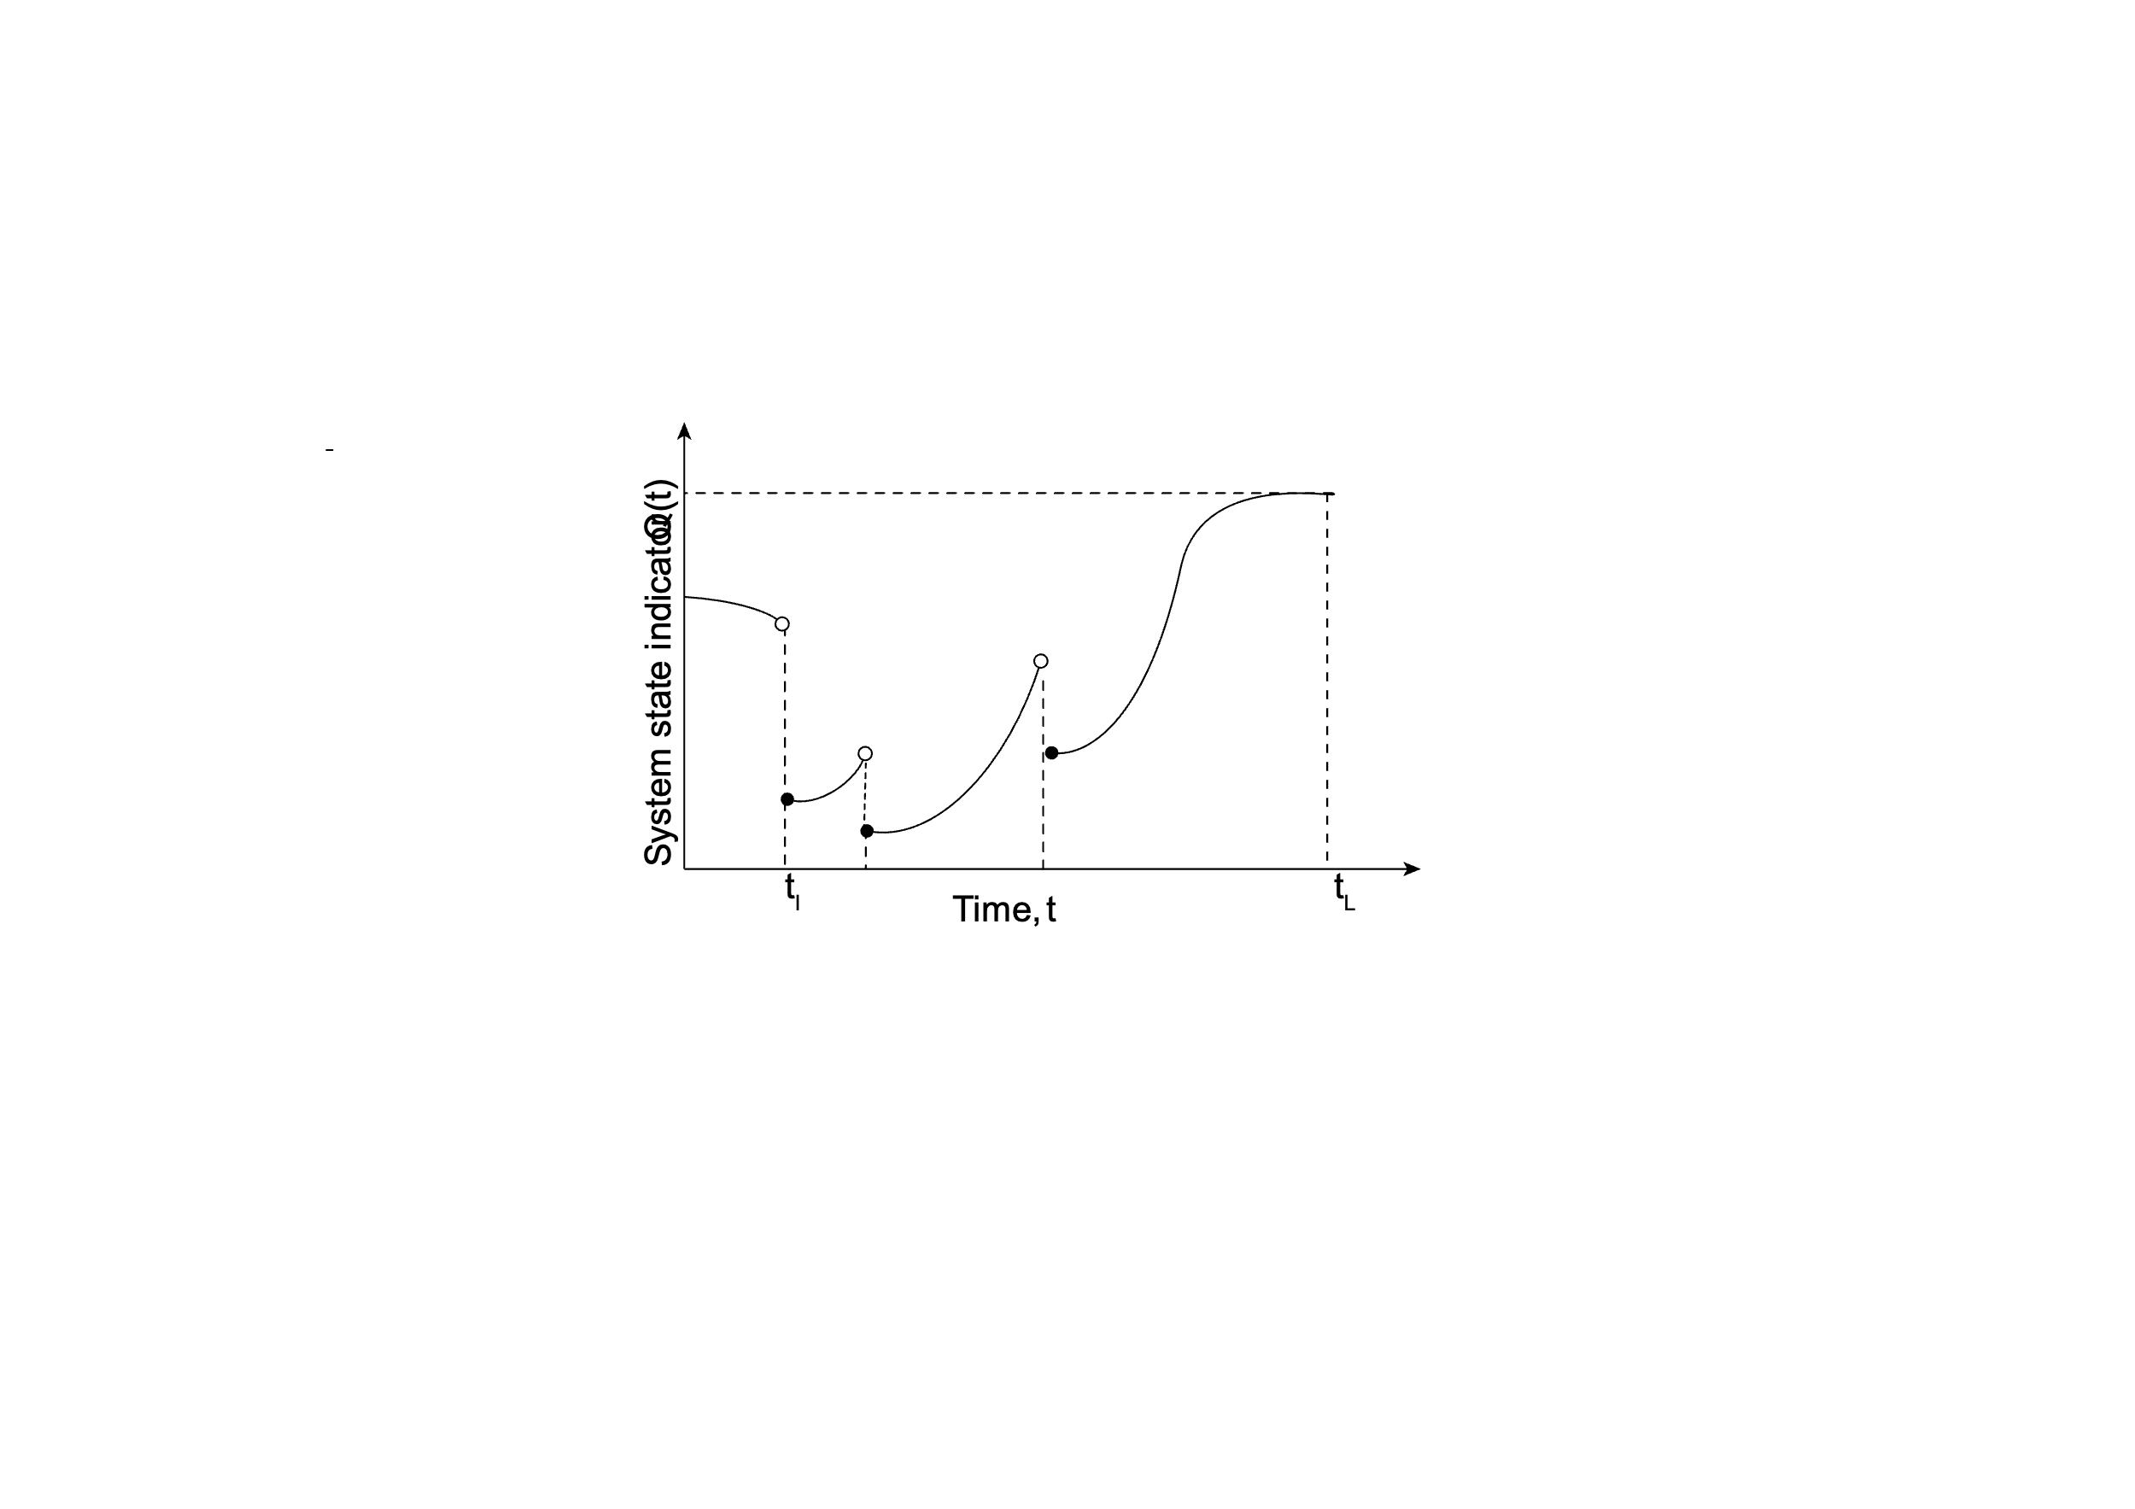The challenge in quantifying resilience includes five aspects (Sharma et al. 2018): (1) different definitions of the term “resilience”; (2) different codes and standards for performance goals; (3) metrics which can fully characterize the recovery curves with different shapes and can distinguish among the different resilience levels; (4) accuracy of the parametric functions; (5) adaptivity among different systems.

**Fig.** A typical recovery process with multi-parallel recovery curve

As we mentioned above, a typical mathematical formulation for resilience with a single metric cannot provide fully information about the recovery process. A recovery process includes the time when an external shock occurs on a system, the system losing its functionality – partial or complete, and the system restoring to its original functionality or a higher one, if desired (Sharma et al. 2018). The recovery curve of a system represents the change of functionality of the system over the recovery time and can be continuous, discrete, or piecewise continuous. Moreover, the recovery curve should provide a fully information for its resilience if properly defined.

Sharma et al. (2018) proposed a mathematical formulation and resilience metrics which have a set of partial descriptors of the recovery curves. The recovery curve is termed as the *Cumulative Resilience Function* (CRF) which is analogous to probability theory. If CRF is a continuous function of time, the derivative of the CRF is termed as *Resilience density function* (RDF) and if CRF is a step function, a *Resilience mass function* has been defined. A significant advantage of the definition of these formulations Is that any types of recovery curves and multiple disruptions can be modeled in theory. Hence, a complete information about the residual state, the recovery process and its resilience can be captured.

A set of partial descriptors are defined includes: (1) *Resilience Disparity*: to capture the degree of disparity between any pairs of recovery curves; (2) *Center of Resilience*: to define the central measures of resilience; (3) *Resilience Bandwidth*: capture the dispersion; (4) *Resilience Skewness*: to determines the degree of asymmetry of the recovery with respect to the Center of Resilience. By using the combination of these partial descriptors, the difference between the recovery curves can be completely captured such as the pair *of Center of Resilience* and *Resilience Bandwidth.*

The phases of the recovery process and their role in resilience quantification will be discussed in the recovery process section in the section 7.

# 7. Recovery and Restoration

## 7.1 Housing recovery: 1000 words - discuss recovery of residential buildings and households after hazards. What is the public assistance available for recovery, who are being mostly affected.

Natural disasters such as Hurricanes often cause severe damage to the coastal community. And the first step to long-term recovery is to re-establish housing (Peacock et al. 2018). For last decades, peoples in the United States mainly relies on the combination of private insurance and limited government assistance to rebuild their houses after the disasters (Comerio 1997). And numerous past cases have highlighted the necessity of extensive personal, public and governmental spending for housing recovery (Sutley and Hamideh 2018). In 1994 Northridge earthquake, there are about 60,000 housing units were severely damaged and the total economic loss was 20 billion dollars (Comerio 1997). Hence, housing recovery is very essential to the community recovery process (Bolin and Stanford 1991).

Khajehei and Hamideh (2023) investigate Lumberton caused by Hurricane Matthew in 2016 and find the challenges of housing recovery. One is that public housing residents have higher vulnerability because of the old structures, poverty, race and housing tenure. Another is lacking transparency of housing recovery policies which delays in completing the recovery process. Furthermore, the destruction and reduction in the number of public housing units led to the long-term displacement of numerous families.

Safapour et al. (2021) study 209 peer-reviewed articles and identify sixty-nine challenges of post-disaster recovery. The main five categories of them are management and coordination, resources, social and cultural, physical and territorial, and legal. The authors find that ineffective management and coordination was widespread existence in most papers and cause the duplications, errors and mistakes during the housing recovery. Also, insufficient financial resources can be another major challenge which lead to serious time delays in the housing recovery process.

The process of housing recovery can be divided into several stages (Sutley and Hamideh 2018). Quarantelli (1985) divide it into four stages including emergency shelter, temporary shelter, temporary housing, and long-term housing. El-Anwar (2010) proposed temporary housing solutions which includes economic, environmental, social and public safety impacts on the community and set up a single-objective optimization problem by maximizing the net social benefit. Also, El-Anwar (2010a, b) developed indices which could measure different kinds of aspects for the social benefits, for instance, housing locations, housing quality, and housing delivery time. Furthermore, El-Anwar (2013)

**7.2** **Infrastructure Recovery:** 500 words – discuss recovery of damaged pipelines, bridges, electrical network, road network due to various hazards in coastal region.

[Cut and paste following paragraph/sentences wherever applicable into previous sections]

Clark et al. (2022) investigates the impacts of economic factors on recovery for hurricane resilience considering wind and storm surge hazards. Their study provides a framework for improved hurricane recovery and resilience of single-family residential homes and the model was validated by using the data from Hurricane Sandy in 2012. At community level, in order to get a high-resolution fragility function under flood hazard, Nofal and van de Lindt (2020) develop a method to model building fragility and loss functions under flood hazards considering not only flood depth, but also flood duration. They used 15 building archetypes to predict damage and functionality which can give recommendations to improve community resilience. Also, with consideration to climate change, Hemmati et al. (2020, 2021) do research on the impact of urban growth subjecting to flood risk and explore quantitative measures of flood impact in order to achieve resilience goals. The climate change effect on flood risk becomes an essential factor of effective flood risk management. In the paper, the author provides the methodology of exposure and risk assessment and hazard assessment and gives some strategies for how to plan for a more resilient communities under flood risk.

Contento et al. (2020) propose a probabilistic formulation to predict storm surge considering climate change and a combination of a logistic model and a non-stationary random field is used. The advantage of the model is that it can be trained using at the same time data form high-fidelity simulations and historical records. Also, the proposed formulation can be used to predict storm surge heights as consideration of climate change effects which can be applicable to coastal area with high-fidelity simulations. However, the predictions of water depth may be low accuracy because the models do not consider local geographical features.

Another key factor to flood vulnerability is how to model hurricane waves and storm surge.

Dietrich et al. (2011) uses a tightly coupled SWAN + ADCIRC model to simulate hurricane waves and storm surge. Tomiczek et al. (2014) investigate the collapse limit state under wave and surge during hurricane hazard. For wave and surge modeling, the author also uses the combined SWAN+ADCIRC wave and circulation model. However, the author considers the fragility from environmental data and fragility using modified slamming force. The model provides correlation with observed patterns of survival and destruction. Baradaranshoraka et al. (2017) propose a methodology to model hurricane-induced surge and compare it with hurricane wind and water model. Ding et al. (2016) propose an integrated coastal and ocean process model for storm surge and waves. Nofal et al. (2021) presents a model to predict damage considering wave and storm surge at the building level and combine them with flood fragilities for the component level.

Masoomi et al. (2019) develop a method to predict hurricane-induced surge and waves as well as winds for wood residential buildings. Do et al. (2016, 2020) propose a performance-based design methodology for inundated elevated coastal structures under hurricane surge and waves.

# 8. conclusions and future directions

***Comprehensive models and multi-hazards***

Most studies now focus on one hazard and use simplified models to simulate the fragility of structures. For instance, Guo uses an integrated Holland model for wind field simulation; Cimellaro et al. (2010a, b) develops an equation for hurricane resilience; Nofal et al. (2020) develops a high-resolution methodology by using Monte Carlo simulation for flood hazards under hurricanes.

However, when a hurricane happens, storm surges, floods, strong wind, and rain are always concomitant. So, in order to simulate the real hurricane hazards in a high resolution, multi-hazard simulation should be considered.

Bhushan et al. (2022) writes a review of multi-hazard resistant structures in the recent decade. Ellingwood et al. (2020) and summarize current limitations in three parts: lack of consideration in codes, metrics for community resilience, and computational toolbox. Pita et al. (2012) develops a method to estimate the component building damage considering wind speed, rain rate, rain duration, and so forth. Tomiczek et al. (2014) investigate the collapse limit state under the wave and surge during hurricane hazards. Ding et al. (2016) propose an integrated coastal and ocean process model for storm surges and waves. Masoomi et al. (2019) develop a method to predict hurricane-induced surges and waves as well as winds for wood residential buildings. Even though, if a model can integrate them together in the future, we can get the most precise result.

***Effective and precise indicators (social, environmental, and structural)***

Another important and tricky problem for community resilience is how to measure the performance of the resilience of structures. Actually, there are many debates about the definition of resilience, and it varies in different disciplines and areas. The common definition of community resilience is the tripartite view of resilience – reducing impacts or consequences, reducing recovery time, and reducing future vulnerabilities. Now, many researchers develop their own resilience indicators and metrics. Ghosn et al. (2016) extend their reliability-based performance indicators for structural members to performance-based criteria for structural systems and infrastructure networks. (Jia et al. 2017; Sharma et al. 2018) use a stochastic model to model the recovery of deteriorated systems. (B. R. Ellingwood et al. 2016, 2018; W. “Lisa” Wang et al. 2022) develop a method to compute the target community metrics for economic and social effects. However, there is no effective indicator that can directly and thoroughly represent the performance of the resilience of structures.

***Interdependency between the systems***

The infrastructure systems include a building system, transportation system, water distribution system, electric power distribution system, and so forth. Recently, most people focus on specific systems such as buildings, and power distribution systems. (Salman and Li 2018) investigate the interconnection of power distribution systems subjected to hurricanes and present a hurricane hazard model to measure system performance.(Bjarnadottir et al. 2018) investigate the effect of climate change on power distribution systems and give six climatic adaptation strategies to mitigate the economic loss of hurricanes.(Mensah and Dueñas-Osorio 2016) propose a resilience assessment framework and develop efficient algorithms to quantify the response of electric power systems during hurricane events. However, if we zoom in on a region or even a city, community resilience is not just depending on one system, the interdependency between the systems plays a good role in community resilience.

# 9. reference

Aaditi, P. (2022, November 10). The Lasting Impacts of Hurricane Ian. Youngzine. Retrieved August 29, 2023, from <https://youngzine.org/news/extreme-events/lasting-impacts-hurricane-ian>

Adhikari, P., Abdelhafez, M. A., Dong, Y., Guo, Y., Mahmoud, H. N., & Ellingwood, B. R. (2021). Achieving residential coastal communities resilient to tropical cyclones and climate change. Frontiers in Built Environment, 6, 576403.

Anwar, G. A., Dong, Y., & Li, Y. (2020). Performance-based decision-making of buildings under seismic hazard considering long-term loss, sustainability, and resilience. Structure and Infrastructure Engineering, 17(4), 454-470.

Arcaya, M., Raker, E. J., & Waters, M. C. (2020). The social consequences of disasters: Individual and community change. Annual Review of Sociology, 46, 671-691.

Bachman, R. E., Hamburger, R. O., Comartin, C. D., Rojahn, C., & Whittaker, A. S. (2003, October). ATC-58 framework for performance-based design of nonstructural components. In Proceedings of ATC-29-2 Seminar on Seismic Design, Performance, and Retrofit of Nonstructural Components in Critical Facilities, ATC-29-2 Report, Applied Technology Council, Redwood City, California (pp. 49-61).

Bandoim, L. (2019, May 03). Hurricane Maria’s Aftermath: Ecological Disaster Continues. Sciencing. Retrieved August 29, 2023, from [https://sciencing.com/hurricane-marias-aftermath-ecological-disaster-continues-13718405.html](file:////Users/cheng/Documents\x/Users/cheng/Desktop/Paper/Bandoim,%20Lana.%20(2019,%20May%2003).%20Hurricane%20Maria's%20Aftermath:Ecological%20Disaster%20Continues.%20Sciencing.%20https:/sciencing.com/hurricane-marias-aftermath-ecological-disaster-continues-13718405.html)

Bănică, A., Kourtit, K., & Nijkamp, P. (2020). Natural disasters as a development opportunity: a spatial economic resilience interpretation. Review of Regional Research, 40, 223-249.

Berg, R. (2009, January 23). Tropical Cyclone Report: Hurricane Ike (AL092008). National Hurricane Center. Retrieved August 29, 2023, from <https://www.nhc.noaa.gov/data/tcr/AL092008_Ike.pdf>

Beven, J. (2005, November 22). Tropical Cyclone Report: Hurricane Dennis (AL042005). National Hurricane Center. Retrieved August 29, 2023, from <https://www.nhc.noaa.gov/data/tcr/AL042005_Dennis.pdf>

Beven, J. L. (2005, April 21). Tropical Cyclone Report: Hurricane Frances (AL062004). National Hurricane Center. Retrieved August 29, 2023, from <https://www.nhc.noaa.gov/data/tcr/AL062004_Frances.pdf>

Beven, J. L., Berg, Robbie., and Hagen, Andrew. (2019, May 17). National Hurricane Center Tropical Cyclone Report: Hurricane Michael (AL142018). National Hurricane Center. Retrieved August 29, 2023, from <https://www.nhc.noaa.gov/data/tcr/AL142018_Michael.pdf>

Beven, J. L., Hagen, Andrew., and Berg, Robbie. (2022, April 4). National Hurricane Center Tropical Cyclone Report: Hurricane Ida (AL092021). National Hurricane Center. Retrieved August 29, 2023, from <https://www.nhc.noaa.gov/data/tcr/AL092021_Ida.pdf>

Beven, J., Cobb, H. (2004, July 1). Tropical Cyclone Report: Hurricane Isabel (AL132003). National Hurricane Center. Retrieved August 29, 2023, from <https://www.nhc.noaa.gov/data/tcr/AL132003_Isabel.pdf>

Beven, J.L., Berg, Robbie., and Hagen, Andrew. (2019, May 17). National Hurricane Center Tropical Cyclone Report: Hurricane Michael (AL142018). National Hurricane Center. <https://www.nhc.noaa.gov/data/tcr/AL142018_Michael.pdf>

Beven, J.L., Hagen, Andrew., and Berg, Robbie. (2022, April 4). National Hurricane Center Tropical Cyclone Report: Hurricane Ida (AL092021). National Hurricane Center. <https://www.nhc.noaa.gov/data/tcr/AL092021_Ida.pdf>

Bolin, R., & Stanford, L. (1991). Shelter, housing and recovery: A comparison of US disasters. Disasters, 15(1), 24-34.

Britannica, T. (2023) Galveston hurricane of 1900. Encyclopedia Britannica. Retrieved September 22, 2023, from <https://www.britannica.com/event/Galveston-hurricane-of-1900>

Bruneau, M., Chang, S. E., Eguchi, R. T., Lee, G. C., O’Rourke, T. D., Reinhorn, A. M., ... & Von Winterfeldt, D. (2003). A framework to quantitatively assess and enhance the seismic resilience of communities. Earthquake spectra, 19(4), 733-752.

Bucci, L., Alaka, L., Hagen, A., Delgado, S., and Beven, J. (2022, September 23-30). National Hurricane Center Tropical Cyclone Report: Hurricane Ian (AL092022). National Hurricane Center. Retrieved August 29, 2023, from <https://www.nhc.noaa.gov/data/tcr/AL092022_Ian.pdf.>

Cangialosi, J. P. and Berg, Robbie. (2021, April 19) National Hurricane Center Tropical Cyclone Report: Hurricane Delta (AL262020). National Hurricane Center. Retrieved August 29, 2023, from <https://www.nhc.noaa.gov/data/tcr/AL262020_Delta.pdf>

Cangialosi, J. P., Latto, A. S., Berg, R. (2018, June 30). National Hurricane Center Tropical Cyclone Report: Hurricane Irma (AL112017). National Hurricane Center. Retrieved August 29, 2023, from [https://www.nhc.noaa.gov/data/tcr/AL112017 \_Irma.pdf.](file:////Users/cheng/Desktop/Paper/ohn%20P.%20Cangialosi,%20Andrew%20S.%20Latto,%20Robbie%20Berg,%20National%20Hurricane%20Center%20Tropical%20Cyclone%20Report:%20Hurricane%20Irma%20(AL112017),%20National%20Hurricane%20Center,%202018.%20June%2030.%20Accessed%20online:%20https:/www.nhc.noaa.gov/data/tcr/AL112017%20_Irma.pdf.)

Cangialosi, J.P. and Berg, Robbie. (April 19) National Hurricane Center Tropical Cyclone Report: Hurricane Delta (AL262020). National Hurricane Center. <https://www.nhc.noaa.gov/data/tcr/AL262020_Delta.pdf>

CBC News. (2022, September 27). Hurricane Fiona changed ocean temperatures, tore up marine life habitats. CBC News. Retrieved August 29, 2023, from <https://www.cbc.ca/news/canada/montreal/storm-fiona-damaged-marine-life-habitats-1.6598025>

CFNJ. (2013, April 1). Hurricane Sandy’s Impact on the Environment. Community Foundation of New Jersey. Retrieved August 29, 2023, from <https://cfnj.org/hurricane-sandys-impact-on-the-environment/>

CGS. (1989). The 1989 Loma Prieta Earthquake. California Department of Conservation. Retrieved August 29, 2023, from [https://www.conservation.ca.gov/cgs/earthquakes/loma-prieta](file:////Users/cheng/Documents\x/Users/cheng/Desktop/Paper/Pararas-Carayannis,%20George.%20(1969,%20May).%20%20The%20April%201,%201946%20Earthquake%20and%20Tsunami%20in%20the%20Aleutian%20Islands.%20The%20Tsunami%20Page%20of%20Dr.%20George%20P.C.%20https:/www.drgeorgepc.com/Tsunami1946.html%20%20%20%20Histroy.com%20Editors.%20(2018,%20March%206).%201964%20Alaska%20Earthquake.%20HISTORY.%20https:/www.history.com/topics/natural-disasters-and-environment/1964-alaska-earthquake%20%20CGS.%20(1989).%201964%20Alaska%20Earthquake.%20CA.%20Gov.%20https:/www.conservation.ca.gov/cgs/earthquakes/loma-prieta)

Chang, S. E., & Shinozuka, M. (2004). Measuring improvements in the disaster resilience of communities. Earthquake Spectra, 20(3), 739–755. <Https://doi.org/10.1193/1.1775796>

Choe, D.-E., Gardoni, P., Rosowsky, D., & Haukaas, T. (2009). Seismic fragility estimates for reinforced concrete bridges subject to corrosion. Structural Safety, 31(4), 275–283. <Https://doi.org/10.1016/j.strusafe.2008.10.001>

Ciampoli, M., & Ellingwood, B. R. (2002). Probabilistic methods for assessing current and future performance of concrete structures in nuclear power plants. Materials and Structures, 35, 3–14. <Https://doi.org/10.1007/BF02482084>

Cimellaro, G. P., Reinhorn, A. M., & Bruneau, M. (2010a). Framework for analytical quantification of disaster resilience. Engineering Structures, 32(11), 3639–3649. <Https://doi.org/10.1016/j.engstruct.2010.08.008>

Cimellaro, G. P., Reinhorn, A. M., & Bruneau, M. (2010b). Seismic resilience of a hospital system. Structure and Infrastructure Engineering, 6(1–2), 127–144. <Https://doi.org/10/cm59v6>

Cimellaro, G. P., Reinhorn, A., & Bruneau, M. (2005, November). Seismic resilience of a health care facility. In Proceedings of the 2005 ANCER Annual Meeting, Session III, November (pp. 10-13).

Clark, R.R. (2005, August). “Hurricane Dennis supplemental damage assessment report.” Florida Department of Environmental Protection. Retrieved August 29, 2023, from <https://floridadep.gov/sites/default/files/HurricaneDennisSupplementalDamageAssessmentReport.pdf>

Cleveland Memory. (2023). The 1924 Lorain, Ohio Tornado. Cleveland Memory. Retrieved August 29, 2023, from <http://www.clevelandmemory.org/lorain/tornado.html>van Noortwijk, J. M., & Frangopol, D. M. (2004). Two probabilistic life-cycle maintenance models for deteriorating civil infrastructures. Probabilistic Engineering Mechanics, 19(4), 345–359.

Comerio, M. C. (1997). Housing issues after disasters. Journal of Contingencies and Crisis Management, 5(3), 166-178.

Deem, D.B. (2002). History of Butler County Missouri: The Poplar Bluff Tornado. USGen Web. Retrieved August 29, 2023, from <https://sites.rootsweb.com/~mobutle2/news/DeemsTornado.html>

Diaz, Jaclyn. (2022, September 23) “5 numbers that show Hurric’ane Fiona’’s devastating impact on Puerto Rico”. NPR News. Retrieved August 29, 2023, from <https://www.npr.org/2022/09/23/1124345084/impact-hurricane-fiona-puerto-rico>

Diaz, Jaclyn. (2022, September 23) “5 numbers that show Hurricane Fiona's devastating impact on Puerto Rico”. NPR News. <https://www.npr.org/2022/09/23/1124345084/impact-hurricane-fiona-puerto-rico>

Dolfman, M. L., Wasser, S. F., & Bergman, B. (2007). The effects of Hurricane Katrina on the New Orleans economy. Monthly Lab. Rev., 130, 3.

ECA. (2014). The Northridge Earthquake: January 17, 1994. Earthquake Country Alliance. Retrieved August 29, 2023, from <https://www.earthquakecountry.org/northridge/facts/>

El-Anwar, O. (2010, May). Optimizing alternative housing projects in the aftermath of natural disasters. In Construction Research Congress 2010: Innovation for Reshaping Construction Practice (pp. 440-448).

El-Anwar, O., El-Rayes, K., & Elnashai, A. S. (2010a). Maximizing the sustainability of integrated housing recovery efforts. Journal of Construction Engineering and Management, 136(7), 794-802.

El‐Anwar, O., El‐Rayes, K., & Elnashai, A. (2010b). Minimization of socioeconomic disruption for displaced populations following disasters. Disasters, 34(3), 865-883.

El-Anwar, O. (2013). Advancing optimization of hybrid housing development plans following disasters: Achieving computational robustness, effectiveness, and efficiency. Journal of computing in civil engineering, 27(4), 358-369.

Eller, A. (2021, April 6). Remembering the Gainesville tornadoes of 1936. AccessWDUN. Retrieved August 29, 2023, from <https://accesswdun.com/article/2021/4/994788/remembering-the-gainesville-tornadoes-of-1936>

Ellingwood, B. R. (2001). Earthquake risk assessment of building structures. Reliability Engineering & System Safety, 74(3), 251–262. <Https://doi.org/10.1016/S0951-8320(01)00105-3>

Ellingwood, B. R., & Mori, Y. (1993). Probabilistic methods for condition assessment and life prediction of concrete structures in nuclear power plants. Nuclear Engineering and Design, 142(2–3), 155–166. <Https://doi.org/10.1016/0029-5493(93)90199-J>

Ellingwood, B. R., van de Lindt, J. W., & McAllister, T. P. (2016). Developing measurement science for community resilience assessment: Preface to the Special Issue of Sustainable and Resilient Infrastructure on the Centerville Testbed. Sustainable and Resilient Infrastructure, 1(3–4), 93–94. <Https://doi.org/10.1080/23789689.2016.1255001>

Esary, J. D., & Marshall, A. W. (1973). Shock models and wear processes. The Annals of Probability, 627–649.

FEMA. (2009, April). “Hurricane Ike in Texas and Louisiana”. FEMA P-757. Retrieved August 29, 2023, from <https://www.fema.gov/sites/default/files/2020-08/fema757.pdf>

Fortenberry, W. (2020, August 3). Tupelo Tornado of 1936. In Mississippi Encyclopedia. Retrieved August 29, 2023, from <http://mississippiencyclopedia.org/entries/tupelo-tornado-of-1936/>

Gardoni, P. (2002). Probabilistic models and fragility estimates for bridge components and systems. University of California, Berkeley.

Gardoni, P. (Ed.). (2017). Risk and Reliability Analysis: Theory and Applications: In Honor of Prof. Armen Der Kiureghian. Springer International Publishing. <Https://doi.org/10.1007/978-3-319-52425-2>

Gardoni, P., Guevara-Lopez, F., & Contento, A. (2016). The life profitability method (LPM): A financial approach to engineering decisions. Structural Safety, 63, 11–20. <Https://doi.org/10.1016/j.strusafe.2016.06.006>

Guidotti, R., Chmielewski, H., Unnikrishnan, V., Gardoni, P., McAllister, T., & van de Lindt, J. (2016). Modeling the resilience of critical infrastructure: The role of network dependencies. Sustainable and Resilient Infrastructure, 1(3–4), 153–168. <Https://doi.org/10.1080/23789689.2016.1254999>

Guidotti, R., Gardoni, P., & Chen, Y. (2017). Network reliability analysis with link and nodal weights and auxiliary nodes. Structural Safety, 65, 12–26. <Https://doi.org/10.1016/j.strusafe.2016.12.001>

Guiney, J. L. (1999, January 9). Preliminary Report: Hurricane Georges (AL071998). National Hurricane Center. Retrieved August 29, 2023, from <https://www.nhc.noaa.gov/data/tcr/AL071998_Georges.pdf>

Guiney, J. L. (1999, January 9). Preliminary Report: Hurricane Georges (AL071998). National Hurricane Center. <https://www.nhc.noaa.gov/data/tcr/AL071998_Georges.pdf>History Channel. (2023). Tri-State Tornado of 1925. History & Society. Retrieved August 29, 2023, from <https://www.britannica.com/event/Tri-State-Tornado-of-1925>

Guiney, J. L., Lawrence, M. B. (1999, January 28). Preliminary Report: Hurricane Mitch (AL131998). National Hurricane Center. Retrieved August 29, 2023, from <https://www.nhc.noaa.gov/data/tcr/AL131998_Mitch.pdf>

Hagy, J.D., Lehrter, J.C. & Murrell, M.C. Effects of Hurricane Ivan on water quality in Pensacola Bay, Florida. Estuaries and Coasts: J ERF 29, 919–925 (2006). <Https://doi.org/10.1007/BF02798651>

Hatzikyriakou, A., & Lin, N. (2018). Assessing the vulnerability of structures and residential communities to storm surge: An analysis of flood impact during Hurricane Sandy. Frontiers in Built Environment, 4, 4.

Hebert, P. J. (1980). Atlantic Hurricane Season of 1979. Monthly Weather Review, 108(7), 973-990. [https://doi.org/10.1175/1520-0493(1980)108<0973:AHSO>2.0.CO;2](https://doi.org/10.1175/1520-0493(1980)108%3c0973:AHSO%3e2.0.CO;2)

Hennessee, L. and Halka, J. (2004). Hurricane Isabel and Shore Erosion: Chesapeake Bay, Maryland. Maryland Geological Survey. Retrieved August 29, 2023, from <http://www.mgs.md.gov/coastal_geology/documents/isabel_erosion_poster.pdf>

Herbert, K. (2014, April 15). Hurricane Rita and the Environmental Impact on Vermillion Parish. ViaNolaVie. Retrieved August 29, 2023, from <https://www.vianolavie.org/2014/04/15/hurricane-rita-and-the-environmental-impact-on-vermillion-parish/>

Histroy. (2018, March 6). 1964 Alaska Earthquake. HISTORY. Retrieved August 29, 2023, from [https://www.history.com/topics/natural-disasters-and-environment/1964-alaska-earthquake](file:////Users/cheng/Documents\x/Users/cheng/Desktop/Paper/Histroy.com%20Editors.%20(2018,%20March%206).%201964%20Alaska%20Earthquake.%20HISTORY.%20https:/www.history.com/topics/natural-disasters-and-environment/1964-alaska-earthquake)

Holling, C. S. (1973). Resilience and stability of ecological systems. Annual Review of Ecology and Systematics, 4(1), 1–23. <Https://doi.org/10.1146/annurev.es.04.110173.000245>

Horton, J. W., Chapman, M. C., & Green, R. A. (2015). The 2011 Mineral, Virginia, earthquake, and its significance for seismic hazards in eastern North America—Overview and synthesis. The 2011 Mineral, Virginia, Earthquake, and Its Significance for Seismic Hazards in Eastern North America, 509, 1-25.

Hurricane Science. (1969). “1969- Hurricane Camille”. Hurricane Science. Retrieved August 29, 2023, from <http://www.hurricanescience.org/history/storms/1960s/camille/>

­Hurricanes. (2023). 2008-Hurricane Ike. Hurricanes: Science and Society. Retrieved September 22, 2023, from <http://www.hurricanescience.org/history/storms/2000s/ike/>

Iervolino, I., Giorgio, M., & Chioccarelli, E. (2013). Gamma degradation models for earthquake-resistant structures. Structural Safety, 45, 48–58. <Https://doi.org/10.1016/j.strusafe.2013.09.001>

Jacobson, S. (2003, July 19). North Brookfield tornado makes one wonder whether big twisters happen here. In a word, yes. Wicked Local. Retrieved August 30, 2023, from <https://www.wickedlocal.com/story/regional/massachusetts/2023/07/19/1953-tornado-worcester-ma-killed-94-people-destroyed-4000-buildings/70424153007/>

Jia, G., Tabandeh, A., & Gardoni, P. (2017). Life-cycle analysis of engineering systems: Modeling deterioration, instantaneous reliability, and resilience. Risk and Reliability Analysis: Theory and Applications: In Honor of Prof. Armen Der Kiureghian, 465–494.

Joanni, A., & Rackwitz, R. (2008). Cost–benefit optimization for maintained structures by a renewal model. Reliability Engineering & System Safety, 93(3), 489–499. <Https://doi.org/10.1016/j.ress.2006.12.014>

Kansas Historical Society. (2004, November). Udall Tornado 1955. Kansas Historical Society. Retrieved August 30, 2023, from <https://www.kshs.org/kansapedia/udall-tornado-1955/12225>

Kennedy, R. P., Cornell, C. A., Campbell, R. D., Kaplan, S., & Perla, H. F. (1980). Probabilistic seismic safety study of an existing nuclear power plant. Nuclear Engineering and Design, 59(2), 315–338. <Https://doi.org/10/fjptg9>

Khajehei, S. (2019). Recovery challenges of public housing residents after disasters: Lumberton, North Carolina after Hurricane Matthew (Doctoral dissertation, Iowa State University).

Khajehei, S., & Hamideh, S. (2024). Post-Disaster Recovery Challenges of Public Housing Residents: Lumberton, North Carolina After Hurricane Matthew. Urban Affairs Review, 60(1), 232-271. <https://doi.org/10.1177/10780874231167570>

Klutke, G.-A., & Yang, Y. (2002). The availability of inspected systems subject to shocks and graceful degradation. IEEE Transactions on Reliability, 51(3), 371–374. <Https://doi.org/10.1109/TR.2002.802891>

Knabb, R. D., Rhome, J.R., Brown, D. P. (2023, January 4). Tropical cyclone Report: Hurricane Katrina (AL122005). National Hurricane Center. Retrieved August 29, 2023, from <https://www.nhc.noaa.gov/data/tcr/AL122005_Katrina.pdf>

Koliou, M., Van De Lindt, J. W., McAllister, T. P., Ellingwood, B. R., Dillard, M., & Cutler, H. (2020). State of the research in community resilience: Progress and challenges. Sustainable and Resilient Infrastructure, 5(3), 131–151. <Https://doi.org/10.1080/23789689.2017.1418547>

Kumar, R., & Gardoni, P. (2014a). Effect of seismic degradation on the fragility of reinforced concrete bridges. Engineering Structures, 79, 267–275. <Https://doi.org/10.1016/j.engstruct.2014.08.019>

Kumar, R., & Gardoni, P. (2014b). Renewal theory-based life-cycle analysis of deteriorating engineering systems. Structural Safety, 50, 94–102. <Https://doi.org/10.1016/j.strusafe.2014.03.012>

Kumar, R., Cline, D. B., & Gardoni, P. (2015). A stochastic framework to model deterioration in engineering systems. Structural Safety, 53, 36–43. <Https://doi.org/10.1016/j.strusafe.2014.12.001>

Kumar, R., Gardoni, P., & Sanchez-Silva, M. (2009). Effect of cumulative seismic damage and corrosion on the life-cycle cost of reinforced concrete bridges. Earthquake Engineering & Structural Dynamics, 38(7), 887–905. <Https://doi.org/10.1002/eqe.873>

KY3. (2022, May 21). Eleven years later: Remembering the May 22, 2011 tornado in Joplin. KY3. Retrieved August 30, 2023, from <https://www.ky3.com/2022/05/21/eleven-years-later-remembering-may-22-2011-tornado-joplin/>

Lawrence, M. B. (2003, April 3). Tropical Cyclone Report: Hurricane Lili (AL132002). National Hurricane Center. Retrieved August 29, 2023, from <https://www.nhc.noaa.gov/data/tcr/AL132002_Lili.pdf>

LSC. (2021, August). Harvey’s Environmental Impacts. Lone Star Legal Aid. Retrieved August 29, 2023, from <https://www.lonestarlegal.org/wp-content/uploads/2021/08/Harvey-Environmental-Impacts-English-1.pdf>

LSU. (1965). Hurricane Betsy, 1965. Louisiana State University. Retrieved August 29, 2023, from <https://guides.lib.lsu.edu/Hurricanes/Betsy>

Mauney, L. (2022). Case study: Hebgen Dam (Montana, 1959). Lessons Learned. Retrieved August 29, 2023, from <https://damfailures.org/case-study/hebgen-dam-montana-1959/>

Mayfield, M. (1999, November 2). Preliminary Report: Hurricane Opal (AL171995). National Hurricane Center. Retrieved August 29, 2023, from <https://www.nhc.noaa.gov/data/tcr/AL171995_Opal.pdf>

McAllister, T. P. (2013). Developing Guidelines and Standards for Disaster Resilience of the Built Environment: A Research Needs Assessment (NIST TN 1795). NIST. <Https://www.nist.gov/publications/developing-guidelines-and-standards-disaster-resilience-built-environment-research>

Mehta, A. (2021). Revitalizing the Puerto Rican Economy After Hurricane Maria. The Cardinal Edge: Vol. 1, Article 7. Retrieved August 29, 2023, from <https://ir.library.louisville.edu/tce/vol1/iss2/7>

Mercy Corps. (2020, August 04). The facts: Hurricane Dorian’s devastating effect on The Bahamas. Mercy Corps. Retrieved August 29, 2023, from <https://www.mercycorps.org/blog/quick-facts-hurricane-dorian-bahamas>

Mieler, M., Stojadinovic, B., Budnitz, R., Comerio, M., & Mahin, S. (2015). A framework for linking community-resilience goals to specific performance targets for the built environment. Earthquake Spectra, 31(3), 1267–1283. <Https://doi.org/10.1193/082213EQS237M>

Mori, Y., & Ellingwood, B. R. (1994). Maintaining reliability of concrete structures. I: Role of inspection/repair. Journal of Structural Engineering, 120(3), 824–845.

Mosher, K. (2002). Sea Science: Floyd Follow-up: The Lingering Effects. North Carolina Sea Grant. Retrieved August 29, 2023, from <https://ncseagrant.ncsu.edu/coastwatch/previous-issues/2000-2/early-summer-2000/sea-science-floyd-follow-up-the-lingering-effects/>

NBC News. (2008, October 5). Environmental damage widespread after Ike. NBC News. Retrieved August 29, 2023, from <https://www.nbcnews.com/id/wbna27034445>

Neal, R. (2005, February 2-4). Impacts of Hurricane Charley on the Southwest Florida Coastline. Florida Shore and Beach Preservation Association. Retrieved August 29, 2023, from <https://fsbpa.com/05Proceedings/01-Robert%20Neal.pdf>

National Geophysical Data Center / World Data Service (NGDC/WDS): NCEI/WDS Global Significant Earthquake Database. NOAA National Centers for Environmental Information. doi:10.7289/V5TD9V7K

NOAA. (1947). The Woodward Tornado of 9 April 1947. National Oceanic and Atmospheric Administration. Retrieved August 29, 2023, from <https://www.weather.gov/oun/events-19470409>

NOAA. (1957). Hurricane Audrey. National Oceanic and Atmospheric Administration. Retrieved September 22, 2023, from <https://www.weather.gov/lch/audrey>

NOAA. (1969, August 17). Hurricane Camille. National Oceanic and Atmospheric Administration. Retrieved August 29, 2023, from <https://www.weather.gov/mob/camille>

NOAA. (1980). Hurricane Allen 1980. National Oceanic and Atmospheric Administration. Retrieved August 29, 2023, from <https://www.weather.gov/lch/1980Allen>

NOAA. (1989). Hurricane Hugo. National Oceanic and Atmospheric Administration. Retrieved August 29, 2023, from <https://www.weather.gov/ilm/hurricanehugo>

NOAA. (1993, April). Hurricane Iniki. National Oceanic and Atmospheric Administration. Retrieved August 29, 2023, from <https://www.weather.gov/media/publications/assessments/iniki1.pdf>

NOAA. (2003). Beecher 50th Anniversary Commemoration: 1953 Beecher Tornado. National Oceanic and Atmospheric Administration. Retrieved August 30, 2023, from <https://www.weather.gov/dtx/beecherfacts>

NOAA. (2004). Frances. National Oceanic and Atmospheric Administration. Retrieved August 29, 2023, from <https://www.weather.gov/mfl/frances>

NOAA. (2005, July 10). Hurricane Dennis – July 10, 2005. National Oceanic Atmospheric Administration. Retrieved August 29, 2023, from <https://www.weather.gov/mob/dennis>

NOAA. (2006). Remembering the May 11, 1953: Waco Tornado. National Oceanic and Atmospheric Administration. Retrieved August 30, 2023, from <https://www.weather.gov/fwd/wacotormay1953>

NOAA. (2020). The Great New England Hurricane of 1938. National Oceanic and Atmospheric Administration. Retrieved September 22, 2023, from <https://www.weather.gov/okx/1938HurricaneHome>

NOAA. (2023, June 29). The 25 Deadliest U.S. Tornadoes. Storm Prediction Center. Retrieved August 29, 2023, from <https://www.spc.noaa.gov/faq/tornado/killers.html>

NOAA National Centers for Environmental Information (NCEI) U.S. Billion-Dollar Weather and Climate Disasters (2023). <https://www.ncei.noaa.gov/access/billions/>, DOI: [10.25921/stkw-7w73](https://www.doi.org/10.25921/stkw-7w73)

NOAA National Centers for Environmental Information (NCEI) U.S. Billion-Dollar Weather and Climate Disasters (2024). <https://www.ncei.noaa.gov/access/billions/>, DOI: [10.25921/stkw-7w73](https://www.doi.org/10.25921/stkw-7w73)

|  |
| --- |
| Nofal, O. M., & van de Lindt, J. W. (2020). High-resolution approach to quantify the impact of building-level flood risk mitigation and adaptation measures on flood losses at the community-level. International Journal of Disaster Risk Reduction, 51, 101903. |
|  |

NYC. (2023). Sandy and Its Impacts. New York City Government. Retrieved September 22, 2023, from <https://www.nyc.gov/html/sirr/downloads/pdf/final_report/Ch_1_SandyImpacts_FINAL_singles.pdf>

O'Connor, J. E., & Costa, J. E. (2003). Large floods in the United States: Where they happen and why (No. 1245). US Geological Survey.

Pararas-Carayannis, G. (1969, May). The April 1, 1946 Earthquake and Tsunami in the Aleutian Islands. The Tsunami Page of Dr. George P.C. Retrieved August 29, 2023, from <https://www.drgeorgepc.com/Tsunami1946.html>

Parrish, J. (1933). The 1933 Long Beach Earthquake. California Department of Conservation. Retrieved August 29, 2023, from <https://www.conservation.ca.gov/cgs/earthquakes/long-beach>

Pasch, R. J., Berg, Robbie., Roberts, D. P., Papin, P. P. (2021, May 26). National Hurricane Center Tropical Cyclone Report: Hurricane Laura (AL132020). National Hurricane Center. Retrieved August 29, 2023, from <https://www.nhc.noaa.gov/data/tcr/AL132020_Laura.pdf>

Pasch, R. J., Brown, D. P., Blake, E. S. (2004, October 18). Tropical Cyclone Report: Hurricane Charley (AL032004). National Hurricane Center. Retrieved August 29, 2023, from <https://www.nhc.noaa.gov/data/tcr/AL032004_Charley.pdf>

Pasch, R.J., Berg, Robbie., Roberts, D.P., Papin, P.P. (2021, May 26). National Hurricane Center Tropical Cyclone Report: Hurricane Laura (AL132020). National Hurricane Center. <https://www.nhc.noaa.gov/data/tcr/AL132020_Laura.pdf>

Pasch, R.J., Kimberlain, T. B., Stewart, S. R. (1999, November 18). Preliminary Report: Hurricane Floyd (AL081999). National Hurricane Center. Retrieved August 29, 2023, from <https://www.nhc.noaa.gov/data/tcr/AL081999_Floyd.pdf>

Peacock, W. G., Dash, N., Zhang, Y., & Van Zandt, S. (2018). Post-disaster sheltering, temporary housing and permanent housing recovery. Handbook of disaster research, 569-594.

Petersen, M. D., Mueller, C. S., Moschetti, M. P., Hoover, S. M., Rukstales, K. S., McNamara, D. E., ... & Cochran, E. S. (2018). 2018 one‐year seismic hazard forecast for the central and eastern United States from induced and natural earthquakes. Seismological Research Letters, 89(3), 1049-1061.

Petersen, M. D., Shumway, A. M., Powers, P. M., Mueller, C. S., Moschetti, M. P., Frankel, A. D., ... & Zeng, Y. (2020). The 2018 update of the US National Seismic Hazard Model: Overview of model and implications. Earthquake Spectra, 36(1), 5-41.

Porter, K. (2021). A Beginner’s Guide to Fragility, Vulnerability, and Risk. In M. Beer, I. A. Kougioumtzoglou, E. Patelli, & I. S.-K. Au (Eds.), Encyclopedia of Earthquake Engineering (pp. 1–29). Springer Berlin Heidelberg. <Https://doi.org/10.1007/978-3-642-36197-5_256-1>

Porter, J. R., Shu, E., Amodeo, M., Hsieh, H., Chu, Z., & Freeman, N. (2021). Community flood impacts and infrastructure: Examining national flood impacts using a high precision assessment tool in the united states. Water, 13(21), 3125.

Quarantelli, E. L. (1985). What is disaster? The need for clarification in definition and conceptualization in research. Disasters and mental health: Selected contemporary perspectives, 41-73.

Raines, H. (1979, September 4). Hurricane Batters the Florida Coast; Damage Widespread. The New York Times. Retrieved August 30, 2023, from <https://www.nytimes.com/1979/09/04/archives/hurricane-batters-the-florida-coast-damage-widespread-path-shifts.html>

Rappaport, E. (1993, December 10). Preliminary Report: Hurricane Andrew. National Hurricane Center. Retrieved August 29, 2023, from <https://www.nhc.noaa.gov/1992andrew.html>

Safapour, E., Kermanshachi, S., & Pamidimukkala, A. (2021). Post-disaster recovery in urban and rural communities: Challenges and strategies. International Journal of Disaster Risk Reduction, 64, 102535.

Sanchez-Silva, M., Klutke, G.-A., & Rosowsky, D. V. (2011). Life-cycle performance of structures subject to multiple deterioration mechanisms. Structural Safety, 33(3), 206–217. <Https://doi.org/10.1016/j.strusafe.2011.03.003>

SCEDC. (2023, August 20). Kern County Earthquake. Southern California Earthquake Data Center. Retrieved August 29, 2023, from <https://scedc.caltech.edu/earthquake/kern1952.html>

SCEDC. (2023, August 21). Santa Barbara Earthquake. Southern California Earthquake Data Center. Retrieved August 29, 2023, from  [https://scedc.caltech.edu/earthquake/santabarbara1925.html](https://scedc.caltech.edu/earthquake/kern1952.html)

Sebastian, T., Lendering, K., Kothuis, B., Brand, N., Jonkman, B., van Gelder, P., ... & Nespeca, V. (2017). Hurricane Harvey Report: A fact-finding effort in the direct aftermath of Hurricane Harvey in the Greater Houston Region.

SFWMD. (2017, September 10). Ecological Effectes of Hurricane Irma. South Florida Water Management District. Retrieved August 29, 2023, from <https://www.sfwmd.gov/science-data/irma-eco-effects>

Sharma, N., Tabandeh, A., & Gardoni, P. (2018). Resilience analysis: A mathematical formulation to model resilience of engineering systems. Sustainable and Resilient Infrastructure, 3(2), 49–67. <Https://doi.org/10.1080/23789689.2017.1345257>

Shumway, A. M., Petersen, M. D., Powers, P. M., Toro, G., Altekruse, J. M., Herrick, J. A., ... & Girot, D. L. (2024). Earthquake Rupture Forecast Model Construction for the 2023 US 50‐State National Seismic Hazard Model Update: Central and Eastern US Fault‐Based Source Model. Seismological Research Letters, 95(2A), 997-1029.

Smith, A. B. (2018). NOAA National Centers for Environmental Information (NCEI). US Billion-Dollar Weather and Climate Disasters.

STEDC. (2018, September). Harvey: The Economic Aftermath. South Texas Economic Development Center. Retrieved August 29, 2023, from <http://stedc.tamucc.edu/files/HARVEY_Update_STEDC_2018Q3.pdf>

Stewart, S. R. (2017, April 7). National Hurricane Center Tropical Cyclone Report: Hurricane Matthew (AL142018). National Hurricane Center. Retrieved August 29, 2023, from <https://www.nhc.noaa.gov/data/tcr/AL142016_Matthew.pdf>

Stewart, S.R. (2017, April 7). National Hurricane Center Tropical Cyclone Report: Hurricane Matthew (AL142018). National Hurricane Center. <https://www.nhc.noaa.gov/data/tcr/AL142016_Matthew.pdf>

Stewart. S. R. (2004, December 16). Tropical Cyclone Report: Hurricane Ivan (AL092004). National Hurricane Center. Retrieved August 29, 2023, from <https://www.nhc.noaa.gov/data/tcr/AL092004_Ivan.pdf>

Strauss, B. H., Orton, P. M., Bittermann, K., Buchanan, M. K., Gilford, D. M., Kopp, R. E., ... & Vinogradov, S. (2021). Economic damages from Hurricane Sandy attributable to sea level rise caused by anthropogenic climate change. Nature communications, 12(1), 2720.

Sturgis, S. (2020, September 11). Hurricane Laura was a toxic harbinger of climate disasters to come. Facing South. Retrieved August 29, 2023, from <https://www.facingsouth.org/2020/809/hurricane-laura-was-toxic-harbinger-climate-disasters-come>

Sutley, E. J., & Hamideh, S. (2018). An interdisciplinary system dynamics model for post-disaster housing recovery. Sustainable and Resilient Infrastructure, 3(3), 109-127.

Sutley, E., Dillard, M., & van de Lindt, J. W. (2021). Community resilience-focused technical investigation of the 2016 Lumberton, North Carolina flood: Community recovery one year later.

Tokgoz, B. E., & Gheorghe, A. V. (2013). Resilience quantification and its application to a residential building subject to hurricane winds. International Journal of Disaster Risk Science, 4(3), 105–114. <Https://doi.org/10.1007/s13753-013-0012-z>

USGS. (1906). “Casualties and damage after the 1906 Earthquake”. United States Geological Survey. Retrieved August 29, 2023, from <https://earthquake.usgs.gov/earthquakes/events/1906calif/18april/casualties.php.>

USGS. (1992). Hurricane Impacts on the Coastal Environment. USGS science for a changing world. Retrieved August 29, 2023, from <https://pubs.usgs.gov/fs/hurricane-impacts/>

USGS. (2021, February 4). 50 Years Later, an Earthquake’s Legacy Continues. USGS science for a changing world. Retrieved August 29, 2023, from <https://www.usgs.gov/news/featured-story/disaster-helped-nation-prepare-future-earthquakes-remembering-san-fernando>

van Noortwijk, J. M., & Frangopol, D. M. (2004). Two probabilistic life-cycle maintenance models for deteriorating civil infrastructures. Probabilistic Engineering Mechanics, 19(4), 345–359. <Https://doi.org/10.1016/j.probengmech.2004.03.002>

van Noortwijk, J. M., & van der Weide, J. A. (2008). Applications to continuous-time processes of computational techniques for discrete-time renewal processes. Reliability Engineering & System Safety, 93(12), 1853–1860. <Https://doi.org/10.1016/j.ress.2008.03.023>

van Noortwijk, J. M., van der Weide, J. A., Kallen, M.-J., & Pandey, M. D. (2007). Gamma processes and peaks-over-threshold distributions for time-dependent reliability. Reliability Engineering & System Safety, 92(12), 1651–1658. <Https://doi.org/10.1016/j.ress.2006.11.003>

Wen, Y. K., Ellingwood, B. R., Veneziano, D., & Bracci, J. (n.d.). Uncertainty Modeling in Earthquake Engineering.

Wilkes, N. (2020, June 21). June 23, 1944 Appalachian Outbreak. Tornado Talk. Retrieved August 29, 2023, from <https://www.tornadotalk.com/june-23-1944-appalachian-outbreak/> van Noortwijk, J. M., & Frangopol, D. M. (2004). Two probabilistic life-cycle maintenance models for deteriorating civil infrastructures. Probabilistic Engineering Mechanics, 19(4), 345–359.

World Vision. (2012). 2012 Hurricane Sandy: Facts, FAQs, and how to help. World Vision. Retrieved August 29, 2023, from <https://www.worldvision.org/disaster-relief-news-stories/2012-hurricane-sandy-facts>

Wortman, M. A., Klutke, G. A., & Ayhan, H. (1994). A maintenance strategy for systems subjected to deterioration governed by random shocks. IEEE Transactions on Reliability, 43(3), 439-445.

Yoder, N. and Moore, S. (2022, June). Murky Waters: An Analysis of Hurricane Ida Pollution Reports. Healthy Gulf. Retrieved August 29, 2023, from <https://healthygulf.org/wp-content/uploads/2023/02/Hurricane-Ida-Pollution-Report-Final.pdf>

1. Ph.D. Candidate, Dept. of Civil Engineering, Case Western Reserve Univ., Bingham 279, 10900 Euclid Ave., Cleveland, OH 44106, e-mail: [mxc1156@case.edu](mailto:mxc1156@case.edu) [↑](#footnote-ref-1)
2. Postdoctoral Researcher, Dept. of Civil, Environmental and Architectural Engineering, Univ. of Kansas, 1530 W. 15th St., Lawrence, KS 66045, e-mail: rkmazumder@ku.edu [↑](#footnote-ref-2)
3. Professor, Dept. of Civil Engineering, Case Western Reserve Univ., Bingham 209, 10900 Euclid Ave., Cleveland, OH 44106; e-mail: [yxl1566@case.edu](mailto:yxl1566@case.edu) [↑](#footnote-ref-3)
4. [↑](#footnote-ref-4)